Position Control of Linear Induction Motor using Adaptive Fuzzy Backstepping Controller with Integral Action

I. K. Bousserhane¹, A. Hazzab¹, M. Rahli², B. Mazari¹, M. Kamli²
¹ University center of Bechar, B.P 417 Bechar 08000, Algeria
² University of Sciences and Technology of Oran, Algeria,
E-mails: bou_isma@yahoo.fr

Abstract - In this paper, the position control of a linear induction motor using adaptive fuzzy backstepping design with integral action is proposed. First, the indirect field oriented control LIM is derived. Then, an integral backstepping design for indirect field oriented control of LIM is proposed to compensate the uncertainties which occur in the control. Finally, the fuzzy integral-backstepping controller is investigated where a simple fuzzy inference mechanism is used to achieve a position tracking objective under the mechanical parameters uncertainties. The effectiveness of the proposed control scheme is verified by numerical simulation. The numerical validation results of the proposed scheme have presented good performances compared to the conventional integral backstepping control.
Key words – linear induction motor, vector control, backstepping design, nonlinear control, fuzzy-backstepping.
- Introduction
Nowadays, LIM’s are now widely used, in many industrial applications including transportation, conveyor systems, actuators, material handling, pumping of liquid metal, and sliding door closers, etc. with satisfactory performance [1]. The most obvious advantage of linear motor is that it has no gears and requires no mechanical rotary-to-linear converters. The linear electric motors can be classified into the following: D.C. motors, induction motors, synchronous motors and stepping motors, etc. Among these, the LIM has many advantages such as high-starting thrust force, alleviation of gear between motor and the motion devices, reduction of mechanical losses and the size of motion devices, high-speed operation, silence, and so on [1, 2]. The driving principles of the LIM are similar to the traditional rotary induction motor (RIM), but its control characteristics are more complicated than the RIM, and the motor parameters are time varying due to the change of operating conditions, such as speed of mover, temperature, and configuration of rail.
Field-oriented control (FOC) or vector control [1, 2, 3] of induction machine achieves decoupled torque and flux dynamics leading to independent control of the torque and flux as for a separately excited DC motor. This control strategy can provide the same performance as achieved from a separately excited DC machine. This technique can be performed by two basic methods: direct vector control and indirect vector control. Both DFO and IFO solutions have been implemented in industrial drives demonstrating performances suitable for a wide spectrum of technological applications. However, the performance is sensitive to the variation of motor parameters, especially the rotor time-constant, which varies with the temperature and the saturation of the magnetising inductance. Recently, much attention has been given to the possibility of identifying the changes in motor parameters of LIM while the drive is in normal operation. This stimulated a significant research activity to develop LIM vector control algorithms using nonlinear control theory in order to improve performances, achieving speed (or torque) and flux tracking, or to give a theoretical justification of the existing solutions [2, 3].
Due to new developments in nonlinear control theory, several nonlinear control techniques have been introduced in the last two decades. One of the nonlinear control methods that have been applied to linear induction motor control is the backstepping design [4, 5]. The backstepping is a systematic and recursive design methodology for nonlinear feedback control. This approach is based upon a systematic procedure for the design of feedback control strategies suitable for the design of a large class of feedback linearisable nonlinear systems exhibiting constant uncertainty, and guarantees global regulation and tracking for the class of nonlinear systems transformable into the parametric-strict feedback form. The backstepping design alleviates some of these limitations [6, 7]. It offers a choice of design tools to accommodate uncertainties and nonlinearities and can avoid wasteful cancellations. The idea of backstepping design is to select recursively some appropriate functions of state variables as pseudo-control inputs for lower dimension subsystems of the overall system. Each backstepping stage results in a new pseudo-control design, expressed in terms of the pseudo-control designs from the preceding design stages. When the procedure terminates, a feedback design for the true control input results which achieves the original design objective by virtue of a final Lyapunov function, which is formed by summing up the Lyapunov functions associated with each individual design stage [4, 5, 6].
In the past years, fuzzy control technique has also been successfully applied to the control of motor drives [8, 9]. The mathematical tool for the FLC is the fuzzy set theory introduced by Zadeh. It can be regarded as nonmathematical control algorithms in contrast to a conventional feedback control algorithm. In the control by fuzzy technique, the linguistic description of human expertise in controlling a process is represented as fuzzy rules or relations. This knowledge base is used by an inference mechanism, in conjunction with some knowledge of the states of the process (say, of measured response variables) in order to determine control-actions. However, the huge amount of fuzzy rules for a high-order system makes the analysis complex. Nowadays, much attention has focused on the combination of fuzzy logic and the backstepping [10, 11]. Fuzzy inference mechanism can arbitrarily approximate nonlinear function and has the superiority of using experiential language information. So, the adaptive fuzzy backstepping controller compensates the uncertainties of the system [11].
In this paper, we apply the fuzzy integral-backstepping technique to design a speed controller for the linear induction motor. The output of the the proposed controller is the current (i_{qs}) required to maintain the motor speed close to the reference speed. The current (i_{qs}) is forced to follow the control current by using current regulators. The indirect field-oriented of linear induction machine is presented in section 2, the integral-backstepping technique for LIM control is summarized in section 3. In section 4, the adaptive fuzzy integral-backstepping design for LIM control is derived. Section 6 concludes the paper.
- indirect field-oriented control of the IM
The dynamic model of the LIM is modified from traditional model of a three-phase, Y-connected induction motor and can be expressed in the d-q synchronously rotating frame as [2, 3]:
$\begin{aligned}\left\{\frac{{\text{di}}_{\text{ds}}}{\text{dt}}=\frac{1}{{σL}_{s}}\left(−\left(R_{s}+{\left(\frac{L_{m}}{L_{r}}\right)}^{2}R_{r}\right)⋅i_{\text{ds}}+σ⋅L_{s}⋅\frac{π}{h}⋅v_{e}⋅i_{\text{qs}}+\frac{L_{m}⋅R_{r}}{L_{r}^{2}}⋅φ_{\text{dr}}+\frac{P⋅L_{m}⋅π}{L_{r}⋅h}⋅φ_{\text{qr}}⋅v_{r}+V_{\text{ds}}\right) | \right.\left\{\frac{{\text{di}}_{\text{qs}}}{\text{dt}}=\frac{1}{{σL}_{s}}\left(−σ⋅L_{s}⋅\frac{π}{h}⋅v_{e}⋅i_{\text{ds}}−\left(R_{s}+{\left(\frac{L_{m}}{L_{r}}\right)}^{2}⋅R_{r}\right)⋅i_{\text{qs}}−\frac{P⋅L_{m}⋅π}{L_{r}⋅h}φ_{\text{dr}}⋅v_{r}+\frac{L_{m}⋅R_{r}}{L_{r}^{2}}⋅φ_{\text{qr}}+V_{\text{qs}}\right) | \right.\left\{\frac{{dφ}_{\text{dr}}}{\text{dt}}=\frac{L_{m}⋅R_{r}}{L_{r}}i_{\text{ds}}−\frac{R_{r}}{L_{r}}⋅φ_{\text{dr}}+\left(\frac{π}{h}⋅v_{e}−P⋅\frac{π}{h}⋅v_{r}\right)⋅φ_{\text{qr}} | \right.\left\{\frac{{dφ}_{\text{qr}}}{\text{dt}}=\frac{L_{m}⋅R_{r}}{L_{r}}⋅i_{\text{qs}}−\left(\frac{π}{h}⋅v_{e}−P⋅\frac{π}{h}⋅v_{r}\right)⋅φ_{\text{dr}}−\frac{R_{r}}{L_{r}}⋅φ_{\text{qr}} | \right.\end{aligned}$ (1)
Where
$σ$ $=1−\left(L_{m}^{2}/L_{s}L_{r}\right)$
$τ_{r}$ $=L_{r}/R_{r}$
$K_{f}$ $3{PπL}_{m}/\left(2{\text{hL}}_{r}\right)$
$R_{s}$ winding resistance per phase;
$R_{r}$ secondary resistance per phase referred primary;
$L_{s}$ primary inductance per phase;
$L_{r}$ secondary inductance per phase;
$L_{m}$ magnetizing inductance per phase;
$h$ pole pitch;
$P$ number of pole pairs;
$v_{e}$ synchronous linear velocity;
$v$ mover linear velocity;
J Inertia moment of the moving element
D viscous friction and iron-loss coefficient
$F_{L}$ external force disturbance.
The main objective of the vector control of linear induction motors is, as in DC machines, to independently control the electromagnetic force and the flux; this is done by using a d-q rotating reference frame synchronously with the rotor flux space vector [3]. In ideally field-oriented control, the secondary flux linkage axis is forced to align with the d-axis, and it follows that [2, 3, 4]:
$φ_{\text{rq}}=\frac{{dφ}_{\text{rq}}}{\text{dt}}=0$ (3)
$φ_{\text{rd}}=φ_{r}=\text{cons}\text{tan}t$ (4)
Applying the result of (3) and (4), namely field-oriented control, the electromagnetic force equation become analogous to the DC machine and can be described as follows:
$F_{e}=K_{f}⋅φ_{r}⋅i_{\text{qs}}$ (5)
And the slip frequency can be given as follow:
$v_{\text{sl}}=\frac{1}{τ_{r}}\frac{i_{\text{qs}}^{}}{i_{\text{ds}}^{}}$ (6)
Consequently, the dynamic equations (1) yield:
$$\begin{aligned}\left\{\frac{{\text{di}}_{\text{ds}}}{\text{dt}}=−\left(\frac{R_{s}}{{σL}_{s}}+\frac{1−σ}{{\text{στ}}_{r}}\right)i_{\text{ds}}+\frac{π}{h}v_{e}i_{\text{qs}}+\frac{L_{m}}{{σL}_{s}L_{r}τ_{r}}φ_{\text{rd}}+\frac{1}{{σL}_{s}}V_{\text{ds}} | \right.\left\{\frac{{\text{di}}_{\text{qs}}}{\text{dt}}=−\left(\frac{R_{s}}{{σL}_{s}}+\frac{1−σ}{{\text{στ}}_{r}}\right)i_{\text{qs}}−\frac{π}{h}v_{e}i_{\text{ds}}+\frac{P⋅L_{m}⋅π}{{σL}_{s}L_{r}h}v_{r}⋅φ_{\text{rd}}+\frac{1}{{σL}_{s}}V_{\text{qs}} | \right.\end{aligned}$$
(7)
The decoupling control method with compensation is to choose inverter output voltages such that:
$V_{\text{ds}}^{}=\left(K_{p}+K_{i}\frac{1}{s}\right)\left(i_{\text{ds}}^{}−i_{\text{ds}}\right)−\frac{π}{h}v_{e}{σL}_{s}i_{\text{qs}}^{}$ (8)
$V_{\text{qs}}^{}=\left(K_{p}+K_{i}\frac{1}{s}\right)\left(i_{\text{qs}}^{}−i_{\text{qs}}\right)+\frac{π}{h}v_{e}{σL}_{s}i_{\text{ds}}^{}+\frac{P⋅L_{m}}{L_{r}}\frac{π}{h}v_{r}φ_{\text{rd}}$ (9)
According to the above analysis, the indirect field-oriented control (IFOC) of induction motor with current-regulated PWM drive system can reasonably presented by the block diagram shown in the Fig. 1.
Fig. 1: Block diagram of IFOC for linear induction motor
LIM
PWM
Invert. r
PARK⁻¹
C_{f}
L_{f}
PARK
IFOC: Indirect Field Oriented Control
-
-
Slip Calc.
-
+
+
+
+
+
+
+
P

- integral-backstepping control of lim
The difficulties in designing a high-performance controller for the aforementioned ac motor servo system derive from the fact that several unknown parameters and disturbances are related to the mechanical uncertainties. The proposed control system is designed to achieve position tracking objective and described step by step as follows.
For the control objective, the position tracking control, we regard the velocity $v_{r}$ as the “control” variable (called virtual control in [12, 13]). Define the position tracking error signal
$e_{1}=d_{\text{ref}}−d$ (10)
Then its error dynamics is
${\overset{˙}{e}}_{1}\left(t\right)={\overset{˙}{d}}_{\text{ref}}\left(t\right)−\overset{˙}{d}\left(t\right)={\overset{˙}{d}}_{\text{ref}}\left(t\right)−v_{r}\left(t\right)$ (11)
If were $v_{r}$ our control, it then can be chosen as
$v_{r}=k_{1}e_{1}+{\overset{˙}{d}}_{\text{ref}}$ (12)
And we will have
${\overset{˙}{e}}_{1}=−k_{1}e_{1}$, $k_{1}>0$ (13)
Let us define a virtual control as [14, 15]
$v_{\text{ref}}=k_{2}χ+k_{1}e_{1}+d_{\text{ref}}$, $k_{2}>0$
With: $χ=\int{e_{1}\left(τ\right)dτ}$ (14)
However, o is not real control. Let us define another error as
$e_{2}=v_{\text{ref}}−v$ (15)
Then we can obtain
${\overset{˙}{e}}_{2}={\overset{˙}{v}}_{\text{ref}}−\overset{˙}{v}={\overset{˙}{v}}_{\text{ref}}−\frac{1}{J}\left(F_{e}−D⋅v−F_{L}\right)$ (16)
Since ${\overset{˙}{v}}_{\text{ref}}=k_{2}\overset{˙}{χ}+k_{1}{\overset{˙}{e}}_{1}+{\overset{¨}{d}}_{\text{ref}}$ (17)
We can rewrite (16)
${\overset{˙}{e}}_{2}=k_{2}\overset{˙}{χ}+k_{1}{\overset{˙}{e}}_{1}+{\overset{¨}{d}}_{\text{ref}}−\frac{1}{J}\left(F_{e}−D⋅v−F_{L}\right)$ (18)
The equation (11) can be rewritten as follows
${\overset{˙}{e}}_{1}=−k_{2}χ−k_{1}e_{1}+e_{2}$ (19)
With $\overset{˙}{χ}=e_{1}$
Let us define the following estimations errors
$\tilde{J}=J−\hat{J}$ (20)
${\tilde{F}}_{L}=F_{L}−F_{L}$ (21)
Then
$\tilde{\overset{˙}{J}}=−\hat{\overset{˙}{J}}$ (22)
${\tilde{\overset{˙}{F}}}_{L}=−{\tilde{\overset{˙}{F}}}_{L}$ (23)
Let us construct a lyapunov function [14, 15]
$V=V\left(χ,e_{1},e_{2},\tilde{J},{\tilde{F}}_{L}\right)$ (24)
$\overset{˙}{V}=\overset{˙}{χ}\frac{∂V}{∂x}+{\overset{˙}{e}}_{1}\frac{∂V}{∂e_{1}}+{\overset{˙}{e}}_{2}\frac{∂V}{∂e_{2}}+\tilde{\overset{˙}{J}}\frac{∂V}{∂\tilde{J}}+{\tilde{\overset{˙}{F}}}_{L}\frac{∂V}{∂{\tilde{F}}_{L}}$ (25)

$\begin{aligned}\overset{˙}{V}=\overset{˙}{χ}\left(\frac{∂V}{∂χ}+k_{2}\frac{∂V}{∂e_{2}}\right)+{\overset{˙}{e}}_{1}\left(\frac{∂V}{∂e_{1}}+k_{1}\frac{∂V}{∂e_{2}}\right) +\frac{1}{J}\left(J{\overset{¨}{d}}_{\text{ref}}+F_{L}−D⋅v−F_{q}\right) \\ ⋅\frac{∂V}{∂e_{2}}−\hat{\overset{˙}{J}}\frac{∂V}{∂\hat{J}}−{\hat{\overset{˙}{F}}}_{L}\frac{∂V}{∂{\hat{F}}_{L}}\end{aligned}$ (25)
Also it is true that
$J{\overset{¨}{d}}_{\text{ref}}=\tilde{J}{\overset{¨}{d}}_{\text{ref}}+\hat{J}{\overset{¨}{d}}_{\text{ref}}$ (26)
$F_{L}={\tilde{F}}_{L}+{\hat{F}}_{L}$ (27)
As a result
$\begin{aligned}\overset{˙}{V}=\overset{˙}{χ}\left(\frac{∂V}{∂χ}+k_{2}\frac{∂V}{∂e_{2}}\right)+{\overset{˙}{e}}_{1}\left(\frac{∂V}{∂e_{1}}+k_{1}\frac{∂V}{∂e_{2}}\right)+\frac{1}{J}\tilde{J}{\overset{¨}{d}}_{\text{ref}}\frac{∂V}{∂e_{2}} \\ +\frac{1}{J}{\tilde{F}}_{L}\frac{∂V}{∂e_{2}}+\frac{1}{J}\left(\hat{J}{\overset{¨}{d}}_{\text{ref}}+{\hat{F}}_{L}−D⋅v−F_{q}\right)\frac{∂V}{∂e_{2}}−\hat{\overset{˙}{J}}\frac{∂V}{∂\tilde{J}}−{\hat{\overset{˙}{F}}}_{L}\frac{∂V}{∂{\tilde{F}}_{L}}\end{aligned}$ (28)
Let
$F_{q}=F_{q1}+F_{q_{2}}$ (29)
$F_{q1}=\hat{J}{\overset{¨}{d}}_{\text{ref}}+{\hat{F}}_{L}$ (30)
Then, we can obtain
$\begin{aligned}\overset{˙}{V}=\overset{˙}{χ}\left(\frac{∂V}{∂χ}+k_{2}\frac{∂V}{∂e_{2}}\right)+{\overset{˙}{e}}_{1}\left(\frac{∂V}{∂e_{1}}+k_{1}\frac{∂V}{∂e_{2}}\right)+\frac{1}{J}\tilde{J}{\overset{¨}{d}}_{\text{ref}}\frac{∂V}{∂e_{2}} \\ +\frac{1}{J}{\tilde{F}}_{L}\frac{∂V}{∂e_{2}}−\frac{1}{J}F_{q_{2}}\frac{∂V}{∂e_{2}}−\hat{\overset{˙}{J}}\frac{∂V}{∂\tilde{J}}−{\hat{\overset{˙}{F}}}_{L}\frac{∂V}{∂{\tilde{F}}_{L}}\end{aligned}$ (31)
Next let
$\frac{∂V}{∂\tilde{J}}=\frac{1}{{\text{Jk}}_{3}}\tilde{J}$ (32)
$\frac{∂V}{∂{\tilde{F}}_{L}}=\frac{1}{{\text{Jk}}_{4}}{\tilde{F}}_{L}$ (33)
Then
$\begin{aligned}\overset{˙}{V}=\overset{˙}{χ}\left(\frac{∂V}{∂χ}+k_{2}\frac{∂V}{∂e_{2}}\right)+{\overset{˙}{e}}_{1}\left(\frac{∂V}{∂e_{1}}+k_{1}\frac{∂V}{∂e_{2}}\right)+\frac{1}{J}\tilde{J}{\overset{¨}{d}}_{\text{ref}}\frac{∂V}{∂e_{2}} \\ +\frac{1}{J}{\tilde{F}}_{L}\frac{∂V}{∂e_{2}}−\frac{1}{J}F_{q_{2}}\frac{∂V}{∂e_{2}}−\frac{1}{{\text{Jk}}_{3}}\tilde{}J\hat{\overset{˙}{J}}−\frac{1}{{\text{Jk}}_{4}}\tilde{}F{\hat{\overset{˙}{F}}}_{L}\end{aligned}$ (34)
Choose the external load estimate update law as
$\hat{\overset{˙}{F}}=k_{4}\frac{∂V}{∂e_{2}}$ (35)
Hence
$\begin{aligned}\overset{˙}{V}=\overset{˙}{χ}\left(\frac{∂V}{∂χ}+k_{2}\frac{∂V}{∂e_{2}}\right)+{\overset{˙}{e}}_{1}\left(\frac{∂V}{∂e_{1}}+k_{1}\frac{∂V}{∂e_{2}}\right)+\frac{1}{J}\tilde{J}{\overset{¨}{d}}_{\text{ref}}\frac{∂V}{∂e_{2}} \\ −\frac{1}{J}F_{q_{2}}\frac{∂V}{∂e_{2}}−\frac{1}{{\text{Jk}}_{3}}\tilde{}J\hat{\overset{˙}{J}}\end{aligned}$ (36)
Any term without $1/J$may be rearranged as
$\left(\right)=\frac{1}{J}J\left(\right)=\frac{1}{J}\tilde{J}\left(\right)+\frac{1}{J}\hat{J}\left(\right)$ (37)
As a result

$$\begin{aligned}\overset{˙}{V}=\frac{1}{J}\tilde{J}\left[\overset{˙}{χ}\left(\frac{∂V}{∂χ}+k_{2}\frac{∂V}{∂e_{2}}\right)+{\overset{˙}{e}}_{1}\left(\frac{∂V}{∂e_{1}}+k_{1}\frac{∂V}{∂e_{2}}\right)\right]+\frac{1}{J}\tilde{J}{\overset{¨}{d}}_{\text{ref}}\frac{∂V}{∂e_{2}} \\ −\frac{1}{{\text{Jk}}_{3}}\tilde{J}\hat{\overset{˙}{J}}+\frac{1}{J}\hat{J}\left[\overset{˙}{χ}\left(\frac{∂V}{∂χ}+k_{2}\frac{∂V}{∂e_{2}}\right)+{\overset{˙}{e}}_{1}\left(\frac{∂V}{∂e_{1}}+k_{1}\frac{∂V}{∂e_{2}}\right)\right]−\frac{1}{J}F_{q_{2}}\frac{∂V}{∂e_{2}}\end{aligned}$$
(38)
Choose the inertia estimate update law as
$\hat{\overset{˙}{J}}=k_{3}\left[\overset{˙}{χ}\left(\frac{∂V}{∂χ}+k_{2}\frac{∂V}{∂e_{2}}\right)+{\overset{˙}{e}}_{1}\left(\frac{∂V}{∂e_{1}}+k_{1}\frac{∂V}{∂e_{2}}\right)+{\overset{¨}{d}}_{\text{ref}}\frac{∂V}{∂e_{2}}\right]$ (39)
Also we can put
$\begin{aligned}F_{q_{2}}=F_{q_{3}}+F_{q_{4}} \\ F_{q_{3}}=\hat{J}\left(k_{2}\overset{˙}{χ}+k_{1}{\overset{˙}{}e}_{1}\right)\end{aligned}$ (40)
Then
$\overset{˙}{V}=\frac{1}{J}\hat{J}\left(\overset{˙}{χ}\frac{∂V}{∂χ}+{\overset{˙}{e}}_{1}\frac{∂V}{∂e_{1}}\right)−\frac{1}{J}F_{q_{4}}\frac{∂V}{∂e_{2}}$ (41)
Suppose there exists an auxiliary function f such that [14]
$\overset{˙}{χ}\frac{∂V}{∂χ}+{\overset{˙}{e}}_{1}\frac{∂V}{∂e_{1}}=f\left(χ,e_{1},e_{2}\right)\frac{∂V}{∂e_{2}}$ (42)
This auxiliary function, f is to be determined later.
$\overset{˙}{V}=\frac{1}{J}\hat{J}⋅f\left(χ,e_{1},e_{2}\right)\frac{∂V}{∂e_{2}}−\frac{1}{J}F_{q_{4}}\frac{∂V}{∂e_{2}}$ (43)
Choose
$F_{q_{4}}=\hat{J}⋅f\left(χ,e_{1},e_{2}\right)+k_{5}\frac{∂V}{∂e_{2}}$ (44)
Then
$\overset{˙}{V}=−\frac{k_{5}}{J}{\left(\frac{∂V}{∂e_{2}}\right)}^{2}≤0, k_{5}>0$ (45)
The inertia estimate update law becomes
$\hat{\overset{˙}{J}}=k_{3}\left[f\left(χ,e_{1},e_{2}\right)+k_{2}\overset{˙}{χ}+k_{3}{\overset{˙}{e}}_{1}+{\overset{¨}{d}}_{\text{ref}}\right]\frac{∂V}{∂e_{2}}$ (46)
Let us put all the components of $F_{q}$together
$F_{q}=\hat{J}{\overset{¨}{d}}_{\text{ref}}+{\hat{T}}_{L}+\hat{J}\left(k_{2}\overset{˙}{χ}+k_{1}{\overset{˙}{e}}_{1}\right)+\hat{J}f\left(χ,e_{1},e_{2}\right)+k_{5}\frac{∂V}{∂e_{2}}$ (47)
We choose
$f\left(χ,e_{1},e_{2}\right)=−\left(k_{2}\overset{˙}{χ}+k_{1}{\overset{˙}{e}}_{1}\right)$ (48)
Then we get the following
$\begin{aligned}F_{q}=\hat{J}{\overset{¨}{d}}_{\text{ref}}+{\hat{F}}_{L}+k_{5}\frac{∂V}{∂e_{2}} \\ \hat{\overset{˙}{J}}=k_{3}{\overset{¨}{d}}_{\text{ref}}\frac{∂V}{∂e_{2}}\end{aligned}$ (49)
$∂V/∂e_{2}$can be chosen to be linear such as
$\frac{∂V}{∂e_{2}}=c_{1}χ+c_{2}e_{1}+c_{3}e_{2}$ (50)
We can choose
$\frac{∂V}{∂e_{2}}=e_{2}$ (51)

We will have then
$\begin{aligned}\hat{\overset{˙}{J}}=k_{3}{\overset{¨}{d}}_{\text{ref}}e_{1} \\ {\hat{\overset{˙}{F}}}_{L}=k_{4}e_{2} \\ F_{q}={\overset{¨}{d}}_{\text{ref}}\hat{J}+{\hat{F}}_{L}+k_{5}e_{2}\end{aligned}$ (52)
$V=\frac{1}{2{\text{Jk}}_{3}}{\hat{J}}^{2}+\frac{1}{2{\text{Jk}}_{4}}{\tilde{F}}_{L}^{2}+\frac{1}{2}e_{2}^{2}+\left(\right), k_{3}>0, k_{4}>0$ (53)
The very last term in V is a part that we do not need to construct explicitly. This explains the name implicit construction of Lyapunov function. Finally, the proposed control law can be shown in the fig. 2 [14, 15].
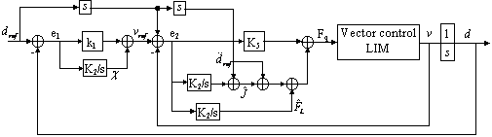
Fig. 2: Block diagram of the adaptive backstepping control

- fuzzy integral-backstepping control of lim
In this section, our objective is to find a robust control law based on the controller of the previous section for LIM position tracking. The adaptive fuzzy-integral backstepping controller is proposed. The proposed fuzzy-integral backstepping controller scheme is shown in Fig. 3. In which a simple fuzzy inference mechanism can replace the first part of the previous controller. The antecedent and consequent parts of the fuzzy inference are shown in Figs. 4 and 5.
In the fuzzy-integral backstepping controller scheme, the error (e) and its first time derivative form the input space of the fuzzy implications of the major switching rule. The triangular membership functions are used for evaluating $d_{\text{ref}}$, where $d_{\text{ref}}$ is the rotor speed reference of the LIM. The i-th fuzzy rule, which incorporates the knowledge and experience of the operator in position control, is expressed as
Rule i: if e is A_{j} and $\overset{˙}{e}$is B_{k} then ${Δd}_{\text{ref}}$is C_{l} (54)
i=1,…,49; j=1,…,7; k=1,…,7; l=1,…,7.
Where A_{j} and B_{k} denote the antecedent parameters and C_{l} denotes the consequent parameter. Because the data manipulated in the fuzzy inference mechanism is based on fuzzy set theory, the associated fuzzy sets involved in the fuzzy control rules are defined as follows:
NB : Negative big | NM : Negative medium
NS : Negative small | ZE : Zero
PS : Positive small | PM : Positive medium
PB : Positive big
The fuzzy rules and parameters of fuzzy inference mechanism for the speed reference generation are shown in Tables 1.

Table 1: fuzzy rules
$e$/$\overset{˙}{e}$ | NB | NM | NS | ZE | PS | PM | PB
NB | NB | NB | NB | NM | NS | NS | ZE
NM | NB | NM | NM | NM | NS | ZE | PS
NS | NB | NM | NS | NS | ZE | PS | PM
ZE | NB | NM | NS | ZE | PS | PM | PB
PS | NM | NS | ZE | PS | PS | PM | PB
PM | NS | ZE | PS | PM | PM | PM | PB
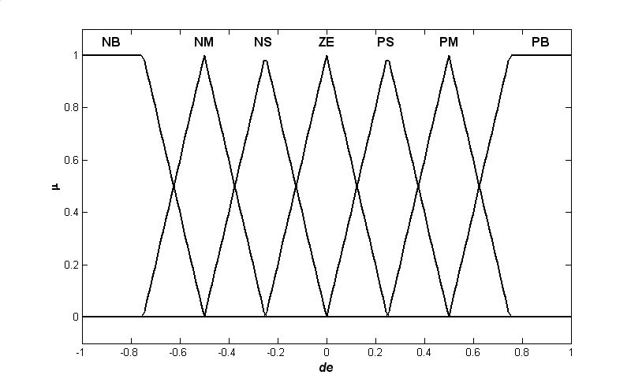  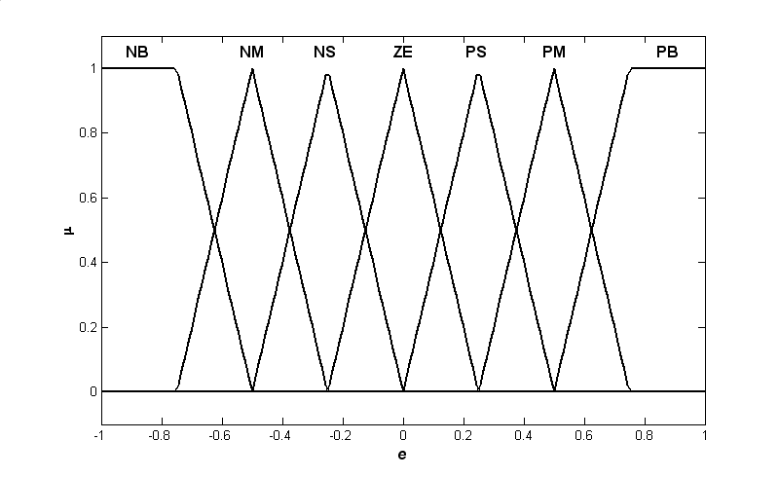  PB  Fig. 3: Membership functions for antecedent part | ZE | PS | PS | PM | PM | PB | PB

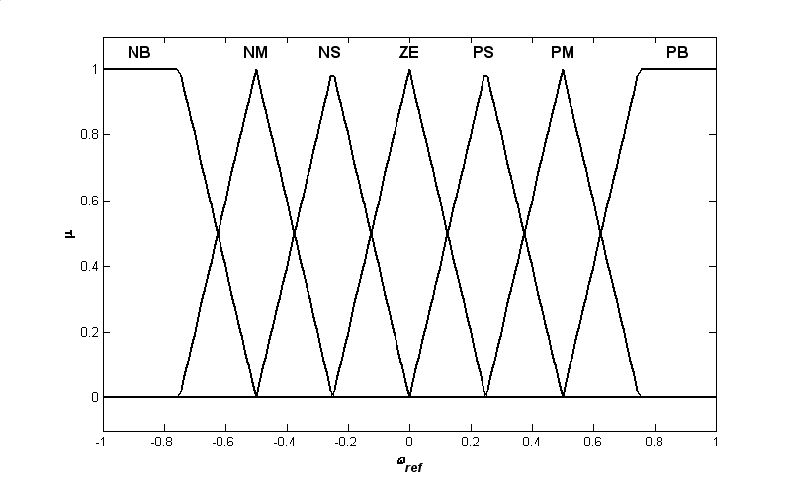
Fig. 4: Membership functions consequent part

Finally, the fuzzy output ${Δv}_{\text{ref}}$can be calculated by the centre of area defuzzification as:
$k^{'}=\frac{\sum_{i=1}^{7}{w_{i}c_{i}}}{\sum_{i=1}^{7}{w_{i}}}=\frac{\left[\begin{matrix}c_{1} & ⋯ & c_{7}\end{matrix}\right]\left[\begin{matrix}w_{1} \\ ⋮ \\ w_{7}\end{matrix}\right]}{\sum_{i=1}^{9}{w_{i}}}=υ^{T}W$ (55)
Where$υ=\left[\begin{matrix}c_{1} & ⋯ & c_{7}\end{matrix}\right]$,$c_{1}$trough $c_{7}$are the centre of the membership functions of ${Δv}_{\text{ref}}$ and $W=\left[\begin{matrix}w_{1} & ⋯ & w_{7}\end{matrix}\right]/\sum_{i=1}^{7}{w_{i}}$ is firing strength vector.
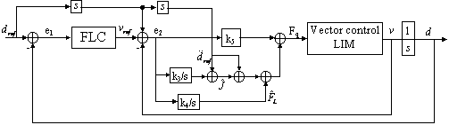
Fig. 5: Block diagram of the fuzzy-integral backstepping control

- simulation results
To prove the rightness and effectiveness of the proposed control scheme, we apply the designed controllers to the position control of the linear induction motor.
First, the simulated results of the fuzzy-integral backstepping control system for periodic sinusoidal and triangular inputs.
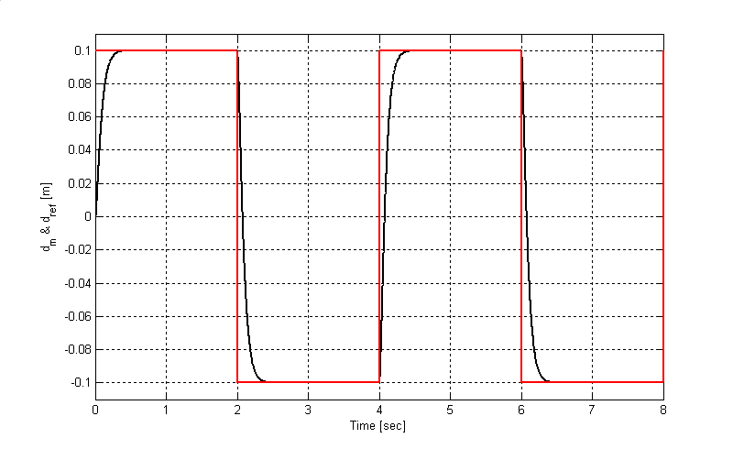
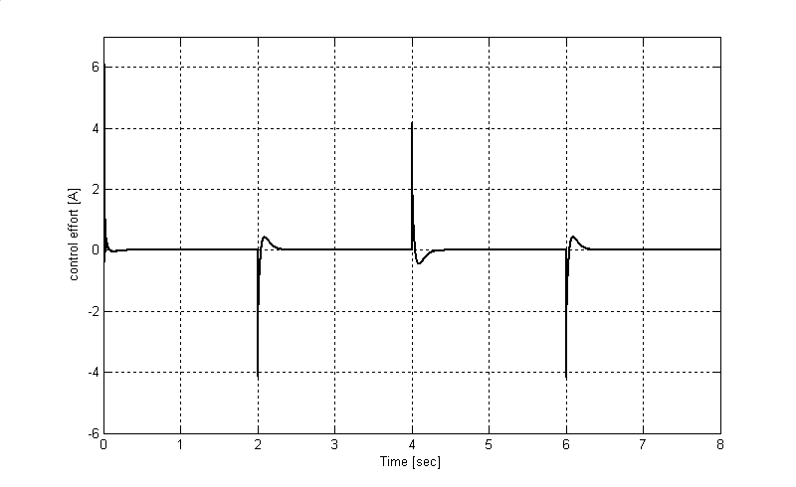
The position responses of the mover and the control effort are shown in Fig. 6. From the simulated results, the proposed fuzzy-integral backstepping controller can track periodic step, sinusoidal and triangular inputs precisely. Next, the simulated results of the fuzzy-integral backstepping control system for periodic step, sinusoidal and triangular inputs with parameters variation are shown in Fig. 7, 8 and 9. From the simulated results, the tracking responses of the fuzzy-integral backstepping control system are insensitive to parameter variations. Moreover, the control efforts are larger than for Case 1 due to the existence of parameter variations. Fig. 10 shows the simulated results of the fuzzy-integral backstepping control system for periodic step, sinusoidal and triangular inputs with force loads disturbance application (constant and sinusoidal force load). From simulated results, the tracking responses of the proposed controller are insensitive to force load application. A comparison between the proposed controller (fuzzy-integral backstepping) and the adaptive integral backstepping is shown in fig. 11 for step and triangular references signal. In Fig. 10, it can be observed that the position response of the fuzz-integral backstepping controller present best tracking responses and very robust characteristics and better that the conventional controller.
Mover position & reference [m]
Control effort [A]

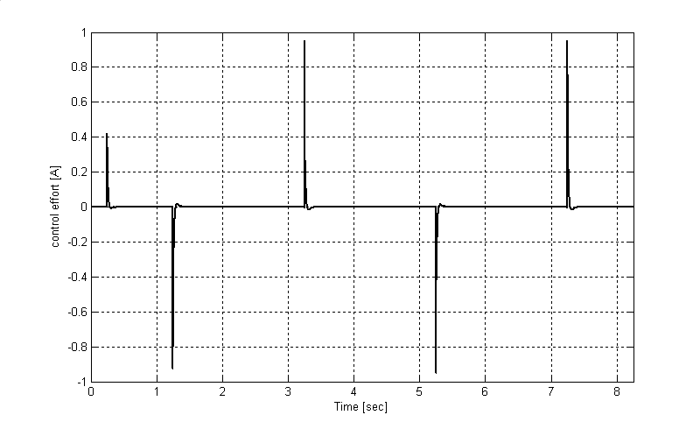
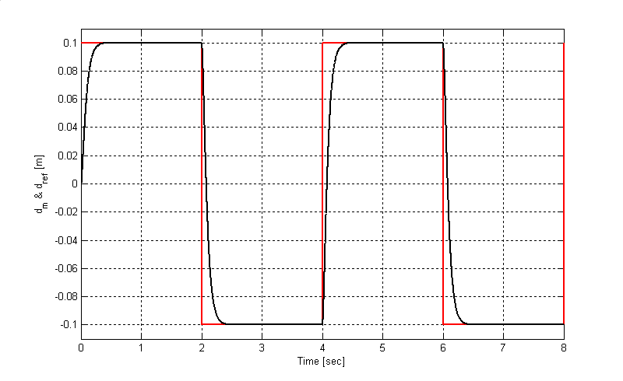
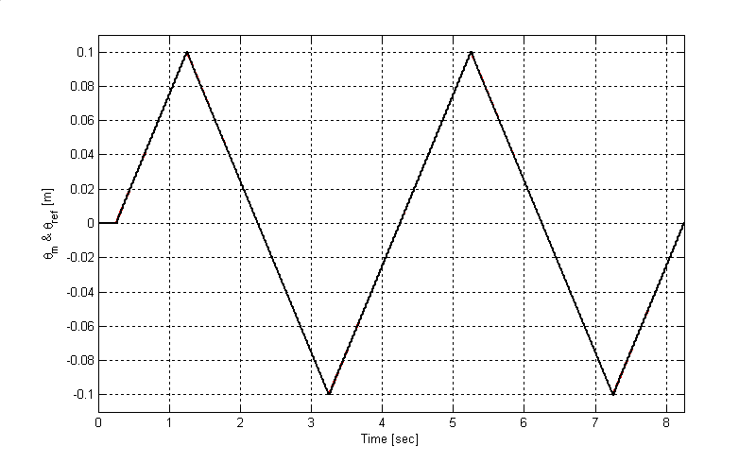
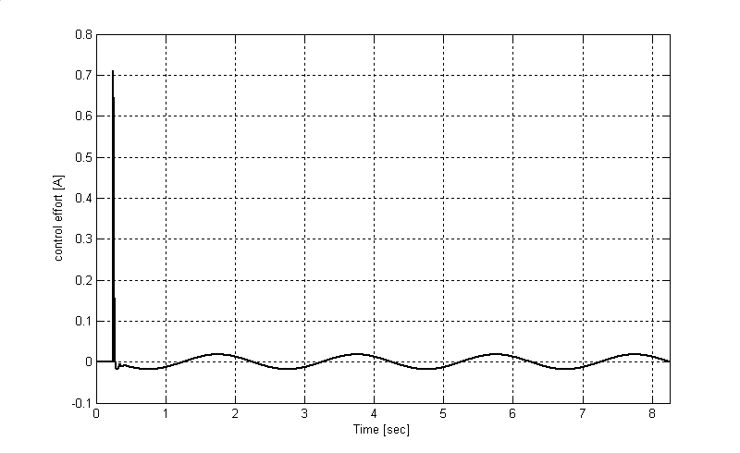
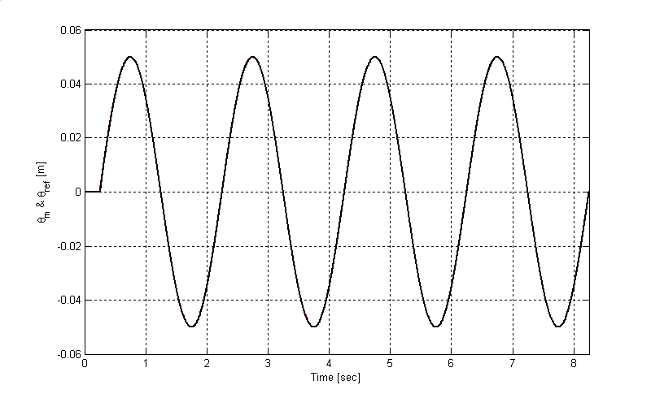
Mover position & reference [m]
Mover position & reference [m]
Control effort [A]
Fig. 6: Simulated results of fuzzy-integral backstepping controller for LIM position control.
Control effort [A]
Mover position & reference [m]

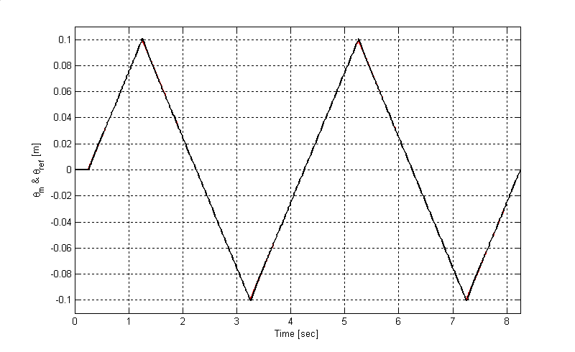
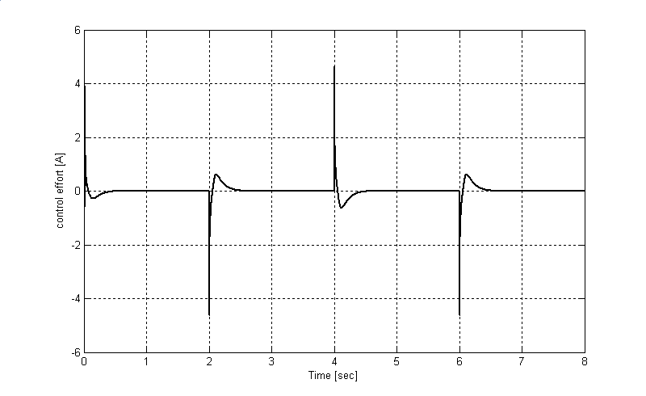
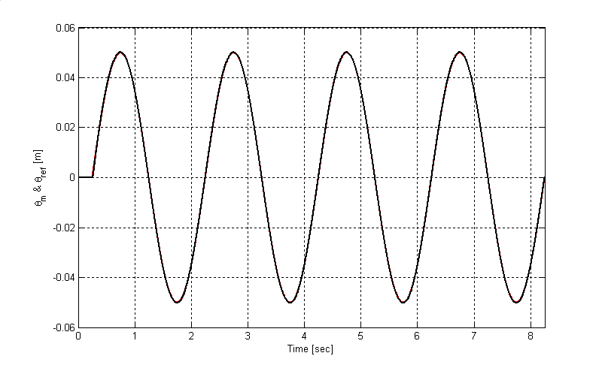
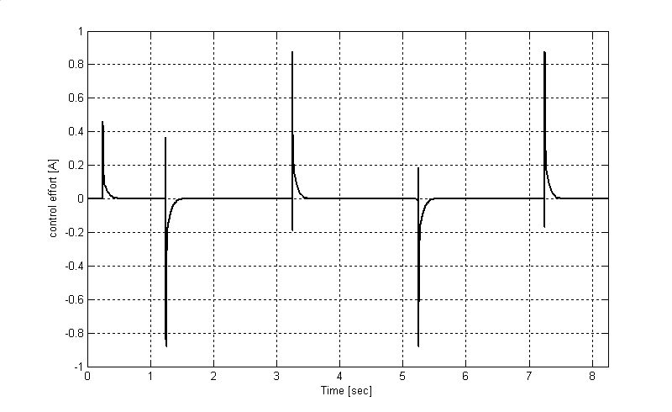
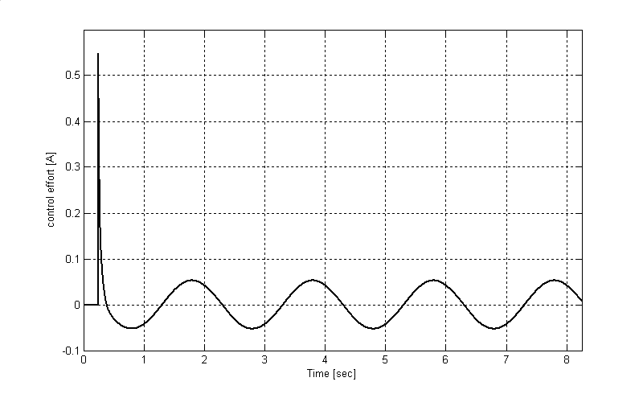
Control effort [A]
Mover position & reference [m]
Control effort [A]
Mover position & reference [m]
Control effort [A]
Fig. 7: Simulated results of the fuzzy-integral backstepping control with rotor resistance variation (3xR_{r n}).

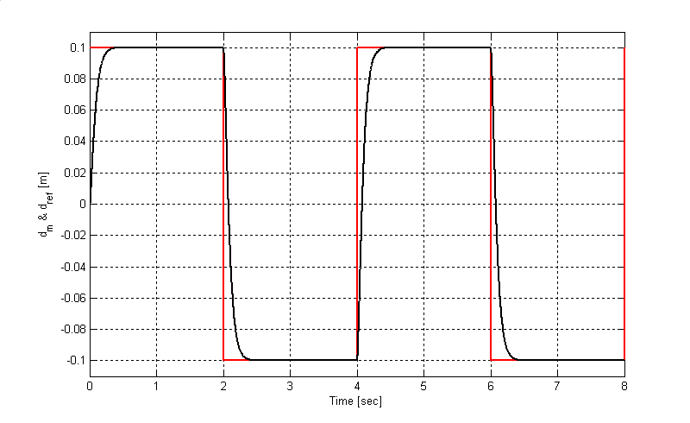
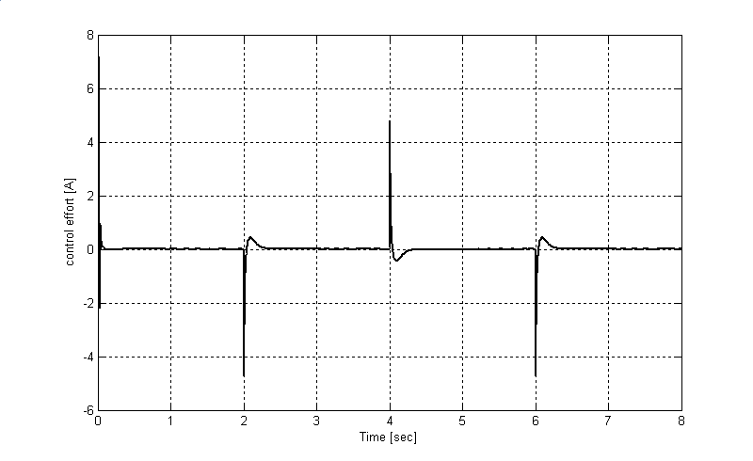
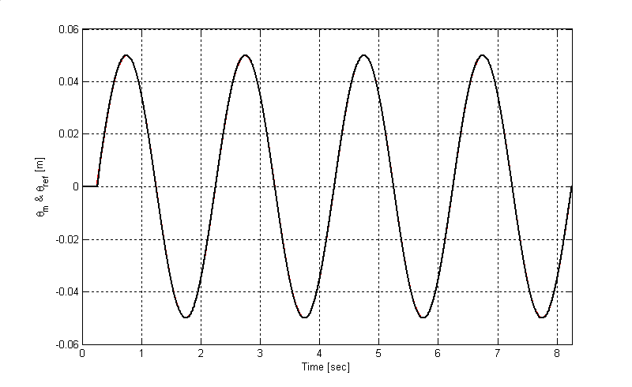
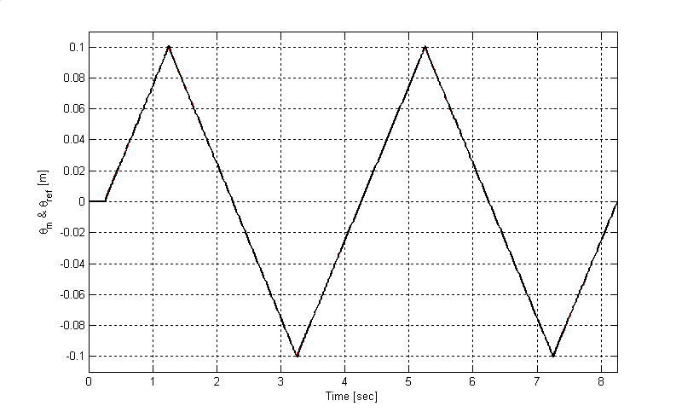
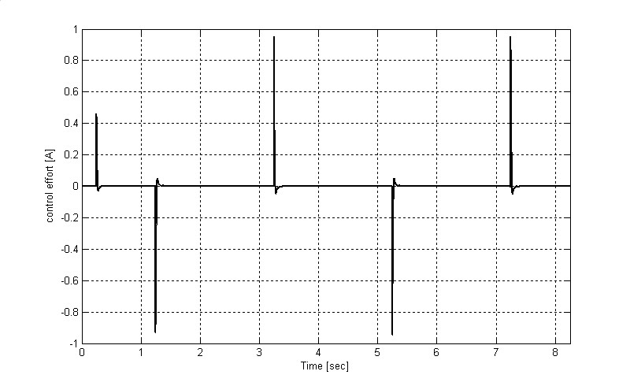
Mover position & reference [m]
Mover position & reference [m]
Control effort [A]
Mover position & reference [m]
Control effort [A]

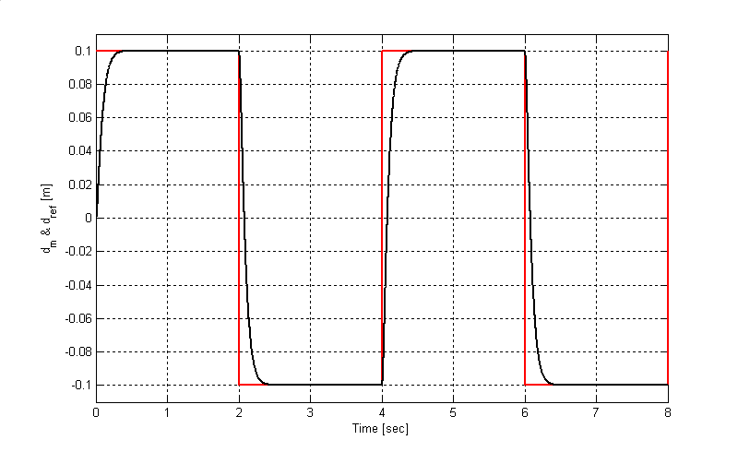
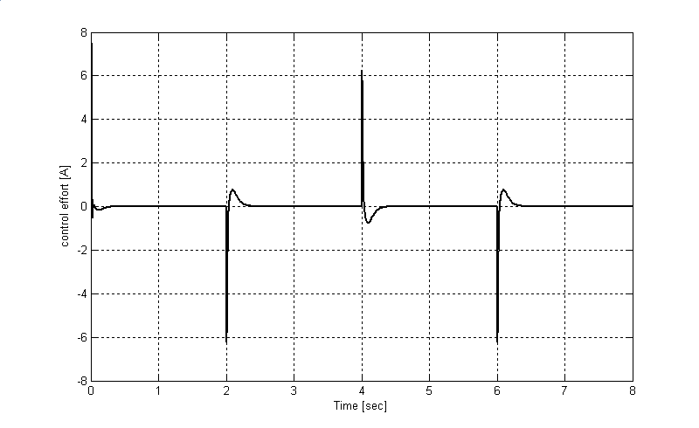
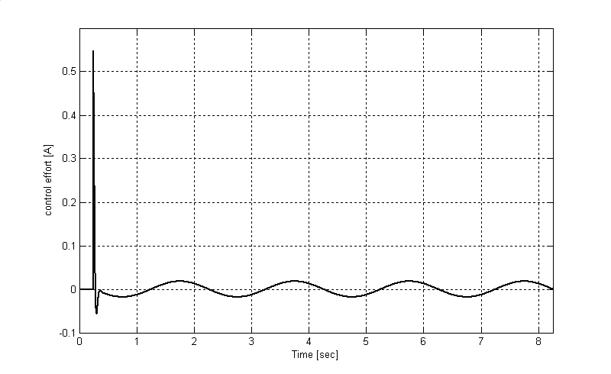
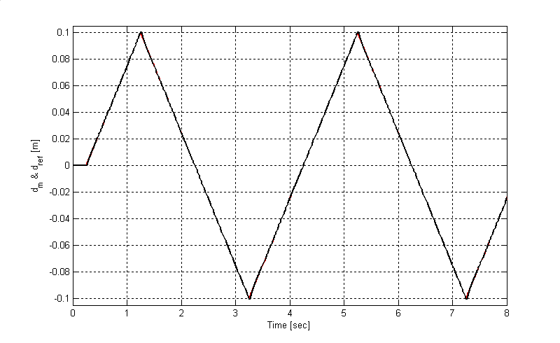
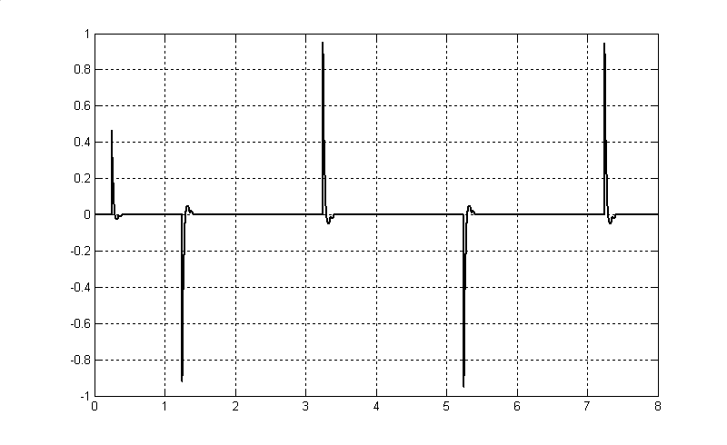
Fig. 8: Simulated results of the fuzzy-integral backstepping control with stator resistance variation (3xR_{s n}).
Control effort [A]
Mover position & reference [m]
Control effort [A]
Mover position & reference [m]
Control effort [A]

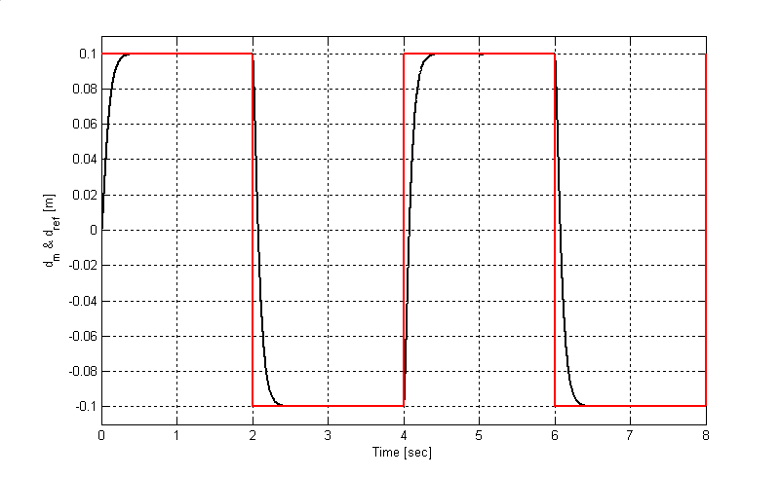
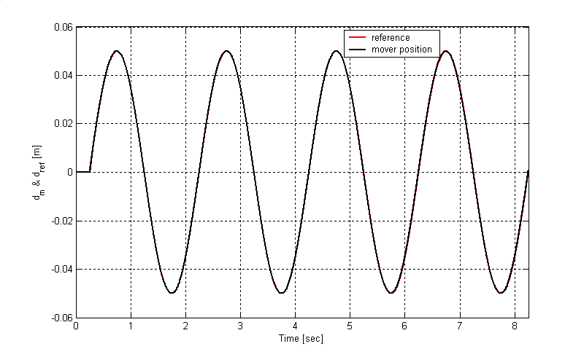
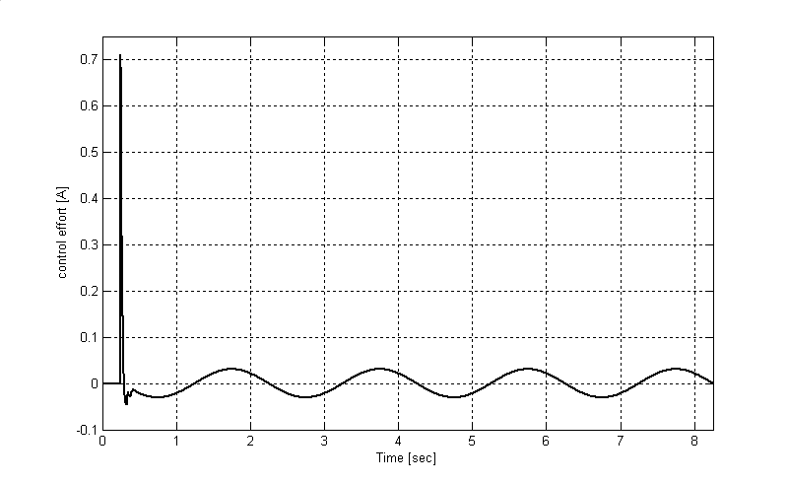
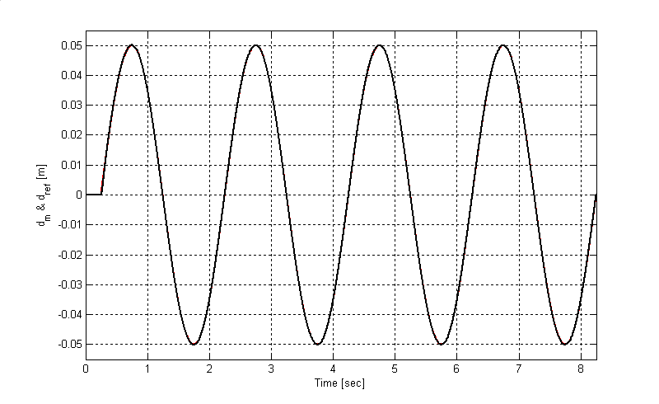
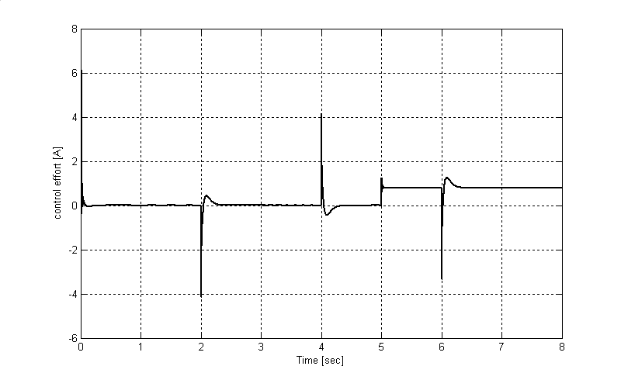
Fig. 9: Simulated results of the fuzzy-integral backstepping control with stator resistance variation (1,7xJ _{n}).
Control effort [A]
Mover position & reference [m]
Mover position & reference [m]
Mover position & reference [m]
Control effort [A]
(a)

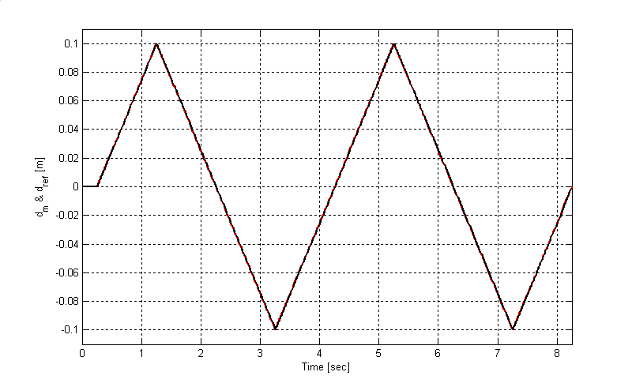
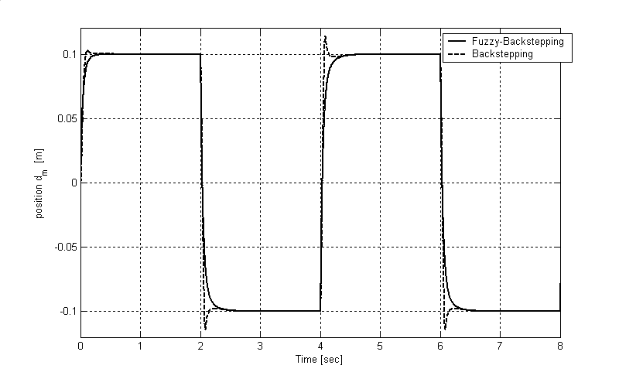
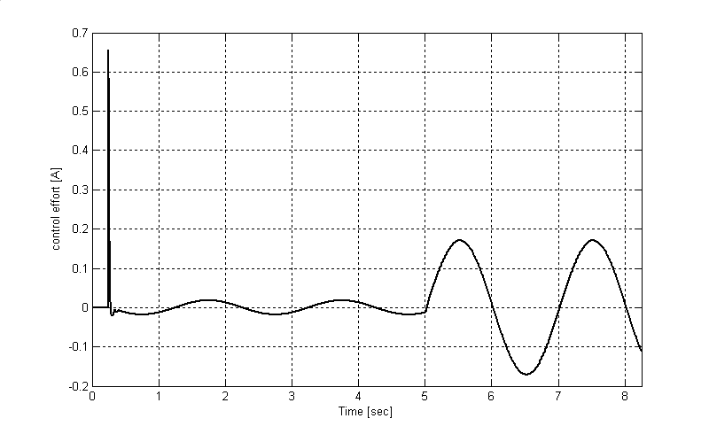
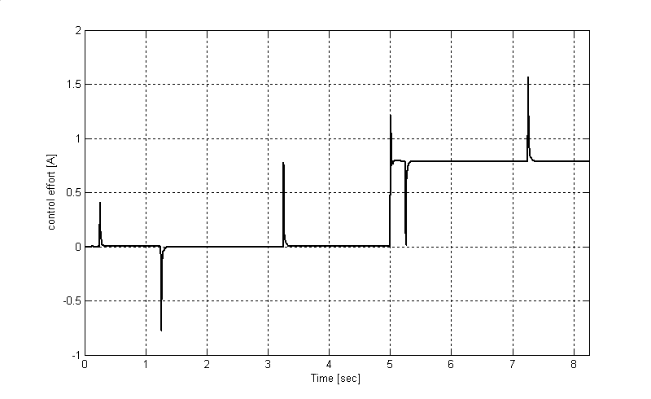
(a)
Control effort [A]
Mover position & reference [m]
Control effort [A]
(b)
(c)
Fig. 10: Simulated results of the fuzzy-integral backstepping control with force load variation for cases:
(a) – Constant force load 20N occurring at 5sec.
(b) – Sinusoidal force load 20.sin(t)N occurring at 5sec.
(c) – Constant force load 20N occurring at 5sec.
Mover position [m]

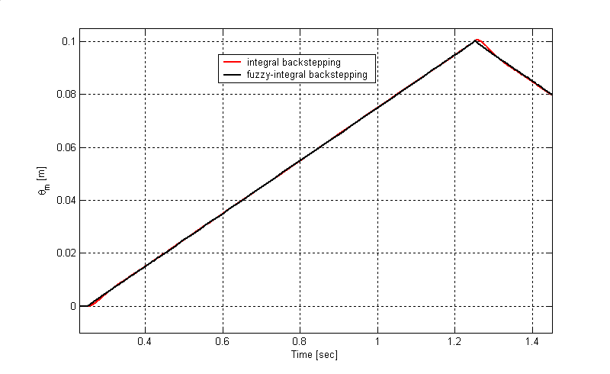
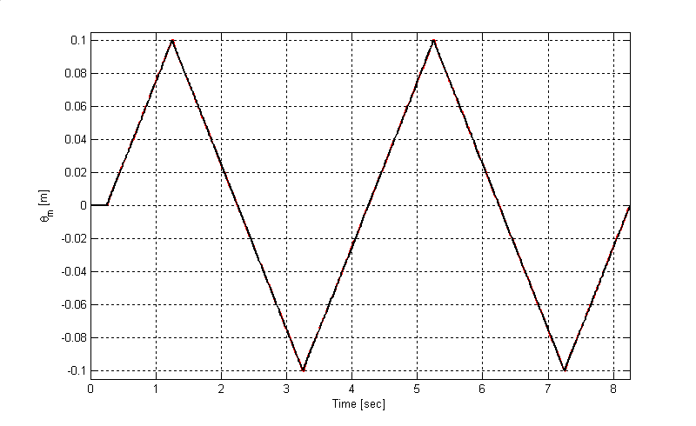
Fig. 10: Simulated results of the comparison between the integral backstepping and the fuzzy-integral backstepping control for LIM control

(b)
(c)
Mover position [m]
Mover position (zoomed responses) [m]

- Conclusion
This paper has demonstrated the applications of a hybrid control system to the periodic motion control of a LIM. First, an integral backstepping controller for LIM control was designed. Moreover, a simple fuzzy inference mechanism was introduced to construct a robust control law based on the conventional controller for LIM position tracking. The control dynamics of the proposed hierarchical structure has been investigated by numerical simulation. Simulation results have shown that the proposed fuzzy-integral backstepping controller is robust with regard to parameter variations and external load disturbance. Finally, the proposed controller provides drive robustness improvement and assures global stability.
- References
- G. Kang and K. Nam, “Field-oriented control scheme for linear induction motor with the end effect”, IEE Proc. Electr. Power Appl., Vol. 152, No. 6, November 2005.
- F. -J. Lin and C.-C.Lee, “Adaptive backstepping control for linear induction motor drive to track periodic references”, IEE Proc. Electr. Power Appl., Vol. 147, No. 6, November 2000.
- E. F. da Silva, E. B. dos Santos, P. C. M. Machado, M. A. A. de Oliveira, “Vector Contol of Linear Induction Motor”, IEEE. ICIT, Mairbor, Slovenia, pp. 518-523, 2003
- R. -J. Wai, F. -J. Lin and S. -P. Hsu, “Intelligent backstepping control for linear induction motor drives”, IEE Proc. Electr. Power Appl., Vol. 148, No. 3, may 2001.
- F. –J. Lin, R. –J. Wai, W. –D. Chou, and S. –P. H., “Adaptive Backstepping Control Using Recurrent Neural Network for Linear Induction Motor Drive”, IEEE Trans. on Indust. Electr. Vol. 49, No. 1, february 2002.
- Kanellakopoulos, I., Kokotovic P.V., and Morse, A. S. ‘Systematic design of adaptive controller for feedback linearizable systems’, IEEE Trans., Auto. Control. 1991. 36. (11), pp. 1241- 1253
- M. Krstié, I. Kanellekapolous, and P. V. Kokotovic, ’Nonlinear Design of Adaptive Controllers for Linear Systems’, IEEE Trans. Automat. Contr., Vol 39, pp. 738-752, 1994.
- C. M. Liaw and F. J. Lin, ‘Position Control with Fuzzy Adaptation for Induction Servomotor Drive’, IEE Proc. Electr. Power. Appl., 142, pp. 397-405.
- LI Zhen, Longya Xu, ‘On-Line Fuzzy Tuning of Indirect Field-Oriented Induction Machine Drives’, IEEE Trans. on Power Electronics, Vol. 13 n°1 (1998).
- P. Carbonnel, Z. P. Jiang. D. W. Repperger, “A fuzzy backstepping controller for pneumatic muscle actuator system”, Proc. Inter. Symp. Intelligent control, 2000, Mexico.
- S. Jagannathan, F. L. Lewis, “Robust backstepping control of a class of nonlinear systems using fuzzy logic”, Information Sciences 123 (2000) 223-240.
- Yaolong, T., Chang, J., Hualin, T., ’Adaptive Backstepping Control and Friction Compensation for AC Servo with Inertia and Load Uncerainties’, IEEE Trans. On Ind. Elect., Vol 50, N°5, 2003.
- Benaskeur, A.R.: ‘Aspects de I’application du backstepping adaptatif à la commande décentralisée des systèmes non-linéaires’. PhD thesis, Department of Electrical and Computer Engineering, Universite Laval, Quebec City, Canada, 2000
- J. –T. Yun and J. Chang, “A new adaptive backstepping control algorithm for motion control systems - an implicit and symbolic computation approach”, Int. J. Adapt. Control Signal Process. 200, Vol. 17, 19–32.
- Y. Tan, J. Chang, H. Tan, and J. Hu, “Integral backstepping control and experimental implementation for motion system”, Proceedings of the IEEE International Conference on Control Applications Anchorage, Alaska, USA, September 25-27,2000.
- F. –J. Lin, P. –H, Shen and S. –P, Hsu, “Adaptive backstepping sliding mode control for linear induction motor”, IEE Proc. Electr. Power Appl., Vol. 149, No. 3, May 2002.

