Robust Nonlinear Speed Tracking Control of Sinusoidal-Field Synchronous Servo Drive Using Adaptive Backstepping Design Strategy

M. ouassaid ⁽¹⁾ , M. Cherkaoui ⁽²⁾ and M. Maaroufi ⁽³⁾

Mohammed V University, Ecole Mohammadia d’ingénieurs, Department of electrical Engineering.
B.P. 765, Agdal, Rabat, Morocco

Email : ⁽¹⁾ ouassaid@emi.ac.ma, ⁽²⁾ cherki@emi.ac.ma, ⁽³⁾maaroufi@emi.ac.ma

Abstract- In this paper a new robust no linear speed tracking control design for Permanent Magnet Synchronous Motor (PMSM) based on adaptive backstepping technique is presented. The backstepping control laws are designed to achieve high-performance speed tracking. The feedback system is globally asymptotically stable in the sense of the lyapunov stability theory.
The PMSM drive systems are often faced with unavoidable and unmeasurable disturbances or some parameter variations. The flux linkage varies non-linearly with the temperature rise. Coupling the load with the motor shaft may cause variations of the inertia and viscous friction despite the load variation. The stator winding resistance may vary due to heating. The adaptive backstepping controller can compensate the unknown system parameters and disturbances, and reject any bounded unmeasurable disturbances entering the system. The obtained performances were improved via the introduction of an integral action in the design procedure. The steady state performances of the backstepping-based controller are, thus, enhanced. In presence of non-zero mean perturbations, this modification guarantees vanishing residual errors. Voltage level control inputs and adaptation laws are designed using adaptive backstepping design methodology.
With the proposed control of speed, the controlled PMSM drive possesses the advantages of good transient performance and robustness to parametric uncertainties. Moreover the proposed control scheme resolves the problem of the disturbance rejection and provides high steady state performances. Finally some comparative simulation results are presented to verify the feasibility and illustrate the performance of the proposed control scheme under the various conditions.
Index terms- Non Linear Control, Stability, Permanent Magnet Synchronous Motors, Adaptive Backstepping, Lyapunov Theory, Precision Control.
I- Introduction

Permanent magnet synchronous motors are receive increased attention for drive applications thanks to their high power factor, superior power density, high torque to inertia ratio, large power to weight ratio, high efficiency, lower loss, lower maintenance, and robustness [1], [2]. These features are due to the improvement of permanent magnet materials.
The traditional and widely used approach to the control of sinusoidal field synchronous motor is Field-Oriented Control (FOC) technique [1]. The FOC represents the attempt to reproduce, for PMSM, a dynamical behaviour similar to that the dc machine, characterized by the fact that developed torque is proportional to the modulus of the stator current. Nevertheless, the performance derived by classical linear controllers, e.g. PI, PID are usually limited due to their sensitivity to non linear behaviour of PMSM dynamics, and load disturbance, when the high performance drive, such as robotics, rolling mills, and machine tools require precise and accurate response, quick recovery from any disturbances, and insensitivity to parameter variations. Recent advances in power electronics and high speed microcontrollers have led to considerable attention in applying control theory to electronically commutated alternate current electrical machines.
In general the mathematical model of an ac motor consists of coupled high-order nonlinear ordinary differential equations representing the dynamics of electrical and mechanical subsystems. Hence, a fully digitally controlled ac motor is a multi-input nonlinear system where the inputs are the phase voltages and the outputs are the position, the velocity, or the torque at the rotor shaft.
Many developments in non-linear system analyses and control technologies suggest that the controllers for electrical motors should be designed directly from nonlinear models. Sliding mode control has been applied to the control of synchronous motors [3]. This technique can offer many advantages, such as invariance condition, insensitivity or robustness, and fast dynamic response. However, changing the inverter switching frequency affects the torque pulsations as much as varying the window size in the hysteresis current controllers, and their effect on the speed was noticeable. More recently, feedback linearization techniques have been extensively applied to the control of electrical machines. The essence of this technique is to first transform a nonlinear system into a linear by means of a nonlinear feedback, and then uses the well-known linear design techniques to complete the controller design [4]. However, it does not guarantee the robustness in the presence of parameter uncertainties or disturbances. Several methods of differential-geometric approach were illustrated by different motors [5].
The past decade has witnessed a rapid emergence of new methodologies for feedback control of non-linear systems. The backstepping [6] is one of the most important results, which provides a powerful design tool. The flexibility of the backstepping method allows it to solve many design problems under restrictive conditions than those encountered in other methods [7]. The adaptive backstepping design offers a choice of design tools for accommodation of uncertainties and nonlinearities and can avoid wasteful cancellations. In addition, the adaptive backstepping approach [6], [8], [9] is capable of keeping almost all the robustness properties of the mismatched uncertainties. The adaptive backstepping is a systematic and recursive design methodology for non-linear feedback control. The basic idea of backstepping design is to select recursively some appropriate functions of state variables as pseudo-control inputs for lower dimension subsystems of the overall system. Each backstepping stage results in a new pseudocontrol design, expressed in terms of the pseudocontrol designs from preceding design stages. When the procedure terminates, a feedback design for the true control input results in achieving of a final Lyapunov function by an efficient original design objective. The latter is formed by summing up the lyapunov functions associated with each individual design stage [6], [8].
In this paper, the backstepping approach is used to design state feedback non-linear control, first under an assumption of known electrical parameters, and then with the possibility of parametric uncertainly and bounded disturbances included. The steady state performances of the backstepping based controller and the problem of the disturbance rejection are enhanced via the introduction of an integral action in the controller.
The remaining sections of this paper are organized as follows. In section II, we describe the PMSM model in a state space form suitable for backstepping control design. In section III, the backstepping controller is derived for the case where the system dynamics are assumed to be completely known. The stability of this controller is proved. In section IV, adaptive backstepping is used to compensate the system parameters used by the controller. Some illustrative simulation results and discussions are presented in section V to validate the proposed controller. Finally some conclusions are mentioned in section VI.

II. Mathematical Model of The PMSM

The electrical and mechanical equations of the PMSM in the rotor reference (dq) frame are described as follows [1]:
(1)
(2)
with
(3)
(4)
where
$vd,vq$ d and q axes stator voltages;
$id,iq$, d and q axes stator currents;
d and q axes stator inductances;
d and q stator flux linkages;
$φm$rotor magnetic flux linking the stator.
R stator resistance;
inverter frequency.
The equation for the motor dynamics is
(5)
where
ω_{r} rotor speed in angular frequency;
J moment of inertia;
B viscous friction coefficient of the motor;
p number of pair poles;
T_{L} load torques;
And the electromagnetic torque is given by
(6)
By choosing () as state variable, the PMSM system can be written in the following explicit form:
$\frac{\text{di}d}{\text{dt}}=\frac{vd}{Ld}−\frac{R}{Ld}id+ω\frac{Lq}{Ld}iq$ (7)
$\frac{\text{di}q}{\text{dt}}=\frac{vq}{Lq}−\frac{R}{Lq}iq−ω\frac{Ld}{Lq}id−ω\frac{φm}{Lq}$ (8)
(9)

III- The Backstepping Controller Design
The form of the nonlinear system, described by (7), (8), and (9), allows the use of the recursive backstepping procedure for the controller design [6], [10]. The method provides basically a recursive framework to construct a lyapunov function and corresponding control action for the system stabilisation. In the rest of this section, this idea is adopted to design a robust nonlinear controller for speed tracking of the PMSM.

Non adaptive case [11]
The system parameters are assumed to be known. First, we start our design by defining the speed tracking control error
(10)
And its dynamics derived from (9)
(11)
Utilizing the backstepping design method, we consider the d-q axes currents components i_{d} and i_{q} as our virtual control elements and specify its desired behavior, which are called stabilising function in the backstepping design terminology as follows:
(12)
(13)
Where$Kω$ and are positive constant at the disposal of the designer and is the integral of the speed tracking error. The effect of integrating this integral action into the stabilizing function will be discussed in section IV.
Since the current components and are not our control inputs, we define
(14)
(15)
Which are the stabilizing errors between and its desired trajectories.
Similarly, our choice of the stabilizing functions and the definition of the stabilizing errors (14), (15) will transform the error dynamics of into the following form
(16)
Furthermore the dynamics of the stabilizing errors can be computed as
$\frac{\text{de}d}{\text{dt}}=−\frac{vd}{Ld}+\frac{R}{Ld}id−ω\frac{Lq}{Ld}iq$ (17)
(18)
Let us define a Lyapunov function for the closed loop system as follows
(19)
The derivative of the Lyapunov function (19) along with the closed loop trajectory (16), (17), and (18) is computed as
(20)
(21)
If the d-q axes control voltages are synthesized as
(22)
(23)
Then, the derivative of the lyapunov function (21) becomes
(24)
where , , and are a positive constant feedback gains. By using LaSalle Yoshizawa’s theorem [6], it can shown that tend to zero as . This implies that the error signals ,, , and converge to zero asymptotically. In particular, the velocity tracking error goes to zero asymptotically.

Adaptive case
In the controller development in the previous section, it was assumed that all the system parameters are known. However, this assumption is not always true. The flux linkage varies nonlinearly with the temperature rise and, also, with the external fields produced by the stator current due to the nonlinear demagnetisation characteristics of the magnet. The winding resistance may vary due to heating. In addition, working condition changes such as load torque and inertia mismatch inevitably impose parametric uncertainties in control system design.
Hence, it becomes necessary to account for all these uncertainties in the design of a high performance controller. We will see how we efficiently handle these uncertainties through step-by-step adaptive backstepping design and parameter adaptations.
In (13), we do not know the exact value of the load torque $TL$; then, it is necessary to estimate them adaptively, and replace them with their estimates .
(25)
So, from (11) and (25) the following speed error dynamics can be deduced
$\frac{\text{de}ω}{\text{dt}}=\frac{1}{J}(−\overset{∼}{TL}+\frac{3Pφm}{2}eq+\frac{3P}{2}\left(Ld−Lq\right)ediq−Kω\text{Je}ω)$ (26)
where $\overset{∼}{TL}=\overset{}{TL}−TL$.
As a result, the d-q currents errors dynamics can be rewritten as
$\frac{\text{de}d}{\text{dt}}=−\frac{vd}{Ld}+\frac{R}{Ld}id−ω\frac{Lq}{Ld}iq$ (27)
(28)
where (29)
Let us define a new lyapunov function for the closed loop system as follows
(30)
Where the stabilizing errors , , , the load torque estimation error , the resistance estimation error , and rotor magnetic flux linking estimation error are all included. And , , and are an adaptation gain. Taking the derivative of (30) and substing (26), (27) and (28) into this derivative we can obtain
(31)
where , , and
(32)
According to the above equation (31), the control laws are now designed as
(33)
(34)
Consequently (31) is simplified to
(35)
The parameter adaptation laws are then chosen as
(36)
(37)
(38)
Then, (35) can be rewritten as follows
(39)
Define the following equation
(40)
Furthermore, by u using LaSalle Yoshizawa’s theorem [6], its can be shown that tends to zero as . So, ${}^{eω}$, ${}^{ed}$and ${}^{eq}$will converge to zero as. Consequently, the proposed controller is stable and robust, despite the parameter uncertainties.

IV- Simulation Results and Discussions
Simulations have been performed to investigate the performance of the proposed nonlinear controllers, and to verify the stability and asymptotic tracking performance. The sample results obtained from simulation are presented in this section.
Digital simulations have been carried out using Matlab/Simulink. The overall block diagram for proposed control scheme is shown in Fig.1. The overall system consists of a non-linear speed tracking controller, a rectifier, a PWM inverter, and a PM synchronous motor.
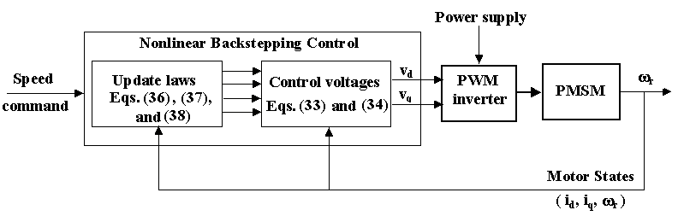
Fig. 1. A block diagram of Robust Nonlinear Control system.

The parameter values used in the ensuing simulations are given in Table I. For the performance comparison, four control methods including the proposed control scheme will be used, which are listed in Table II
First, the case of non-adaptive backstepping control without integration (Method A) for PMSM is taken into consideration. Fig. 2 illustrates motor speed, speed tracking error and current responses, when the drive system is started at a constant load of 1.25N.m. A step load torque of 1.5T₀ is applied to the motor shaft at t = 0.2s and removed at t = 0.4s.
It is observed that a steady-state error in the speed response exists. We can also see, that the load variation increases the tracking error. This can be improved by introducing the integral action. Fig.3 shows the tracking performance of method B. As shown in this illustrated figure, the tracking speed response can be effectively improved by using this control scheme under load variation. However, the determination of the closed-loop feedback constants was obtained after some search effort, and stable operation with good performance in steady state requires a judicious choice of integral gain.
Now, the method C is considered. In figure 4, the tracking control with nominal drive parameters is shown.

Speed (rad/s) | 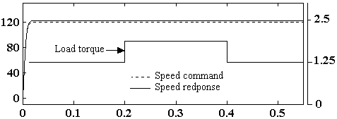
Speed error (rad/s) | 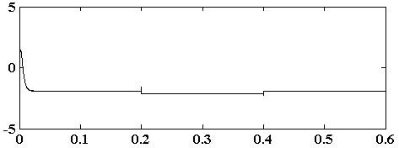
Current i_{d}, i_{q} (A) | 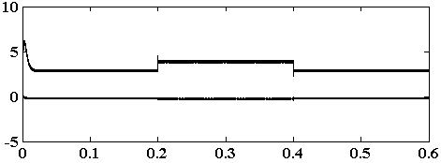
 | Time (s)
Fig.2. Tracking Performance of Non Adaptive Backstepping control without integration

Speed (rad/s) | 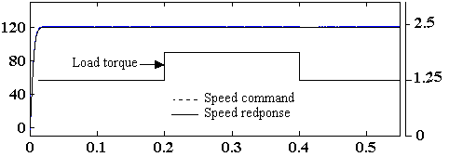
Speed error (rad/s) | 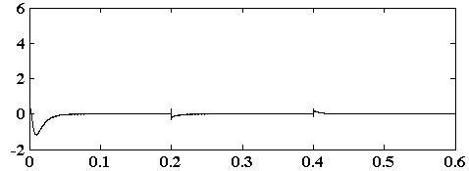
Current i_{d}, i_{q} (A) | 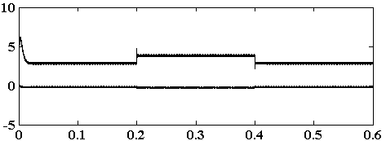
 | Time (s)
Fig.3. Tracking Performance of Non Adaptive Backstepping control with integral action

This version also fails, to eliminate the steady state errors. Thus, the introduction of the system parameter and disturbance estimates cannot be an effective way in reducing the steady state error to zero. The steady state performances of the adaptive backstepping controller are enhanced via the introduction of an integral action in the controller. Fig. 5 shows the tracking performance of adaptive backstepping control with integral action under the nominal parameters motor drive.
According to this figure, the trajectory command can be well tracked and the speed error converged to zero. The actual speed does not change during load variation. The adaptation scheme for the load disturbance can quickly recognize the variation and compensate them eventually. This illustrates the capability of the proposed controller in terms of disturbance rejection.
As compared with the previous methods in Fig. 2, 3, and 4 the error speed response in Fig. 6 shows a high dynamic performance under both parameter variations and external mechanical disturbances: 30% in the stator resistance, -20% in the rotor flux linkage, and 200% in the mechanical inertia. This can be explained by the simultaneous introduction of the integral action and the system parameter and disturbance estimates.
In order to demonstrate the robustness of the new control scheme, we also implemented a traditional plus integral (PI) control scheme. Fig.7 shows, from the start and for a load disturbance, the transient speed responses. We can see that the proposed controller can quickly and accurately track the desired reference better than the PI controller. When the drive is subjected to some abrupt load, the velocity shows a good disturbance characteristic suppression in the proposed control when compared with the linear control. Under parameter perturbations, with the linear controller (PI), speed-tracking performance is deteriorated. In Fig.8, the speed transient response shows large and undesirable transient error in start up. Fig.9 shows the speed error response when an abrupt load variation is applied. It can be seen that the speed error for

Speed (rad/s) | 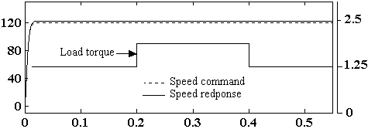
Speed error (rad/s) | 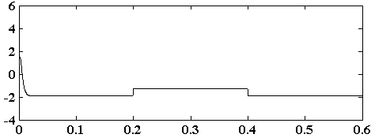
 | Time (s)
Fig.4. Tracking Performance of Adaptive Backstepping control without integration

Speed (rad/s) | 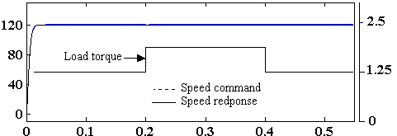
Speed error (rad/s) | 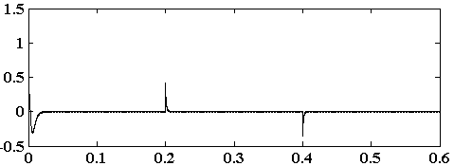
 | Time (s)
Fig.5. Tracking Performance of Proposed Control.

Speed (rad/s) | 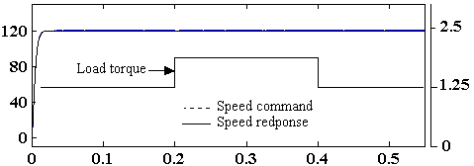
Speed error (rad/s) | 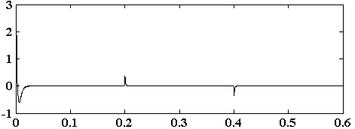
 | Time (s)
Fig.6. Tracking Performance of Proposed Control with perturbed parameters.

PI controller shows remarkable transient before it settles to zero, while the proposed controller is unaffected by this variation.
From the results presented earlier, it is quite evident that the proposed technique control gives high and robust performances against the inaccuracy in the modelling of the parameter motor drive and its variations.

V. Conclusion
In this paper the velocity control problem of Sinusoidal-Field Synchronous servo drive was addressed. The nonlinear behavior of the system, non-matched perturbations, parameter variations and load torque disturbance limits the performances of classical linear controllers used for this purpose. The backstepping design strategy was adopted to develop a nonlinear controller that takes all uncertainties and system non-linearities into account. An integral action was also introduced in order to improve the steady state performance. As a result, an excellent speed tracking performance and a zero steady state error were obtained under the variation of the motor parameters, and the occurrence of uncertainties acting in the entire electromechanical system. Compared with other backstepping design methods the proposed control improves the dynamic performance and also extends the stability margins in cases of large perturbations appearing in practical drive applications.
According to the various comparative simulations results mentioned above, it is verified that the proposed control scheme provides a robust control performance under the presence of the parameter variation and external disturbances caused by the inertia and load changes. This paper has successfully demonstrated, stability analysis, and simulation of a robust adaptive backstepping control system for the PMSM drives.

Speed (rad/s) | 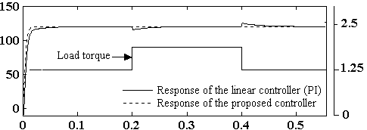
Speed error (rad/s) | 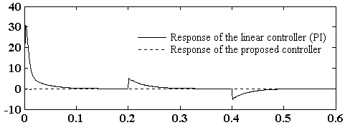
 | Time (s)
Fig.7. Speed transient responses for a starting and a sudden increase in load of a PI-controlled system and proposed control scheme.

Speed error (rad/s) | 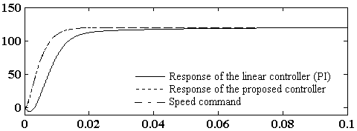
 | Time (s)
Fig.8. Comparison of transient response for the PI controlled system and proposed controller
under , and .

Speed (rad/s) | 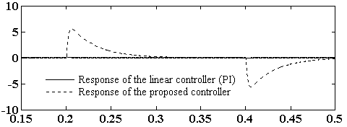
 | Time (s)
Fig.9. Comparison of rejection disturbance under load variation (+50% at 0.2s and –50% at 0.4s) of the PI controlled system and proposed controller with , and .

Table I
Parameter Values of PMSM used in Simulation

Number of pole pairs P | 2
Armature resistance R | 3 Ω
Magnet flux linkage φ_{m} | 0.167Web
d-axis inductance L_{d} | 7mΩ
q-axis inductance L_{q} | 7mΩ
Moment inertia J | 0.1314 10⁻³ kgm²
Rated voltage | 200V
Rated power | 500 w

Table II

Four Control Methods for The Performance Comparison

Method A | Non-adaptive backstepping control  without integration (K1 = 0).
Method B | Non-adaptive backstepping control  with integral action (K1 =10⁷).
Method C | Adaptive backstepping control  without integration (K1 =0).
Proposed | Robust adaptive backstepping control (K1 =10⁶).

References
- P. Pillay, R. Krishnan, “Modeling, simulation, and analysis of permanent-magnet motor drives. I. The permanent-magnet synchronous motor drive,” IEEE Transactions on Industry Applications, Vol. 25 Mar/Apr 1989, pp. 265 –273.
- Pragasem Pillay, Romu Krishan, “ Application characteristics of PMS and brushless dc motors for servo drivers,” IEEE Transactions on Industry Applications, Vol. 27, N° 5, Sep/Oct 1991, pp. 986-996.
- F. J. Lin, S. L. Chiu, and K. K. Shyu, “ Novel Sliding Mode controller for synchronous motor drive “, IEEE Transactions on Aerosp. Electron.Syst. Vol. 34, April 1998, pp. 532-542.
- J. J. E. Slotin and W.Li , “Applied Nonlinear Control.” Englwood Cliffs, NJ: Prentice-Hall 1991.
- Marc Bodson and John chiasson, “Differential geometric methods for control of electric motors”, Int. J.Robust Non linear control 8, 923-954.
- M. Krstić, I. Kanellakopoulos, and P.V.Kokotović “Nonlinear and Adaptive Control Design.” New York: Wiley Interscience, 1995.
- Benaskeur A.R., Paquin L.N. and Desbiens A., “Toward industrial control applications of the backstepping “, Process Control and Instrumentation, 2000, Glasgow, Scotland, pp. 62-67.
- Faa-Jeng Lin, Rong-Jong Wai Wen-Der Chou, and Shu-Peng Hsu “Adaptive Backstepping control Using Recurrent Neural Network for Induction Motor Drive,” IEEE Transactions on Industrial Electronics, Vol. 49, N° 1, February 2002, pp. 134-146.
- D.G. Taylor, “Non-linear control of electric machines: an overview,” Control Systems Magazine, IEEE Vol. 14, N° 6, Dec 1994, pp. 41-51.
- M. Ouassaid, M. Cherkaoui and Y. Zidani,” A Nonlinear Speed Control for PM Synchronous Motor Using Adaptive Backstepping Control Approach”. Proc. Of the IEEE International Conference on Industrial Technology, Vol. 3, December 2004, pp. 1287-1292.
- M. Ouassaid, M. Cherkaoui and M. Maaroufi, ” Improved Nonlinear Velocity Tracking Control for Synchronous Motor Drive Using Backstepping Design Strategy” . Proc. Of the IEEE Power’Tech International Conference, June 2005.
- Parechc. Sen,“Electric motor drives and control, past, present, and future,” IEEE Transactions on Industrial Electronics, Vol. 37, N° 6, Dec 1990, pp. 562-575.
- Hisn-Jang Shieh and Kuo-Kai Shyu, “Non Linear Sliding Mode Torque Control With Adaptive Backstepping Approach For Induction Motor Drive,” IEEE Transactions on Industrial Electronics, Vol. 46, N° 2, April 1999, pp. 380-388.
- R. B. Sepe and J. H. Lang , “Real time adaptive control of the Permanent Magnet Synchronous Motor,” IEEE Trans on Industry Applications, Vol. 27, July/Aug. 1991, pp. 706-714.
- A. Verl and M. Bodson, “ Torque maximization for Permanent Magnet Synchronous Motors“, IEEE Trans on Cont. Sys. Techol. Vol. 6, Nov 1998, pp. 740-745.
- P.V. Kokotovic, , “The joy of feedback: non-linear and adaptive “, Control Systems Magazine, IEEE Vol. 12, N° 3, Jun 1992, pp. 7-17.

