Contribution to the Modeling of the Non-Destructive Testing Process
by the Conformal Mapping Method

Kamel SRAIRI and Mohamed SEBAÏ
LESM, Laboratory of Energy Systems Modeling
Department of Electrical Engineering, University of Biskra
BP 145, Biskra 07000, Algeria. Phone/Fax: + 213 33 74 9154, Email: ksrairi@yahoo.fr

Mouloud FELIACHI
Research laboratory in Inductive Techniques/ IUT Saint Nazaire
LRTI-GE44/BP 406 Bd de l'Université, 44602 Saint Nazaire Cedex/ France

Abstract: The subject of this article is about the development of mathematical transformations applied to simulation models of signal by eddy current. It will be suitable to study using the conformal mapping technique, how to come up with a simple configuration of a problem from a complex one with difficult or impossible modeling. The method of finite element is used to evaluate of the electromagnetic size. The method of developed bijective transformation is applied to the study of a sensor-charge system. The validity of that model is verified by comparing the results to the analytical calculation data.
Key words: numerical modeling, non destructive testing, eddy currents, conformal mapping.

1. Introduction
The non destructive testing (NDT) by eddy currents, remains always the object of vast research undertaken by the scientific community. This fact is well illustrated by the significant number of contributions presenting of the various formulations for the evaluation of eddy currents [3].
The modeling of control by eddy currents proves to be an invaluable tool for the comprehension of the experimental results, the optimization of probes or, the simulation of configurations or defects difficult to realize in experiments. The existing software of simulation currently is founded on digital techniques. They require in certain situations a power and a time extremely high computing and exploitation, in particular, in the structures with complex configurations and when the work frequencies are relatively significant. The research tasks undertaken in this field, aim at, and the development of a whole of simplified direct models intended for the modeling
of control by eddy currents.

In this article, the study and the development of direct mathematical transformations and opposite applied to models of simulation of the signals by eddy current are presented.

2. Definition of the problem
That is to say a sensor deformed in a plane configuration called starting system (Figure 1.a). This system is considered in physico-geometrical matter difficult to model. In order to determine his electromagnetic fields, in fact, (magnetic induction, currents induced, impedance...), one will apply a direct bijective mathematical transformation, thus we obtain an equivalent geometrical model, and which normally must be easy to model (Figure 1b).

Sensor
Load
a
b

Fig. 1. Geometrical models
- starting Configuration
- equivalent Configuration

Our contribution consists in preceding the modeling of the equivalent geometrical model by the finite element method (FEM) to determine its electromagnetic fields. Thereafter, and by an opposite vectorial transformation applied to the physical results (magnetic induction, potential vector...) thus obtained by modeling the equivalent geometrical model, we obtain the values of electromagnetic fields of the configuration of the departure without passing by its own modeling.
To validate this procedure suggested, we are obliged to choose a relatively simple starting model to be able to apply the FEM to the starting model for the resolution of the characteristic partial derivative equations with the electromagnetic phenomena in question (the potential vector, magnetic induction, the induced currents, impedance).
The values of these sizes thus obtained will be taken as values of reference. The results obtained by the opposite vectorial transformation, applied to the physical sizes given by the modeling of the equivalent geometrical model, will be compared with these values of reference.
The degree of validity of our model will depend primarily on the variations thus obtained of the comparison.

3. Electromagnetic formulations for the non destructive testing
Control by eddy currents is based on the laws of magnetic induction. One calls eddy current, the currents induced in a conducting material by a variation of the magnetic flow of induction. According to the Lenz' law, these currents develop so as to be opposed to the phenomenon which gave them birth.
One can in this manner of injecting electromagnetic energy in the part to be controlled without there being contact. Via adequate measurements, the evolution of this energy will give access to certain information in physical and geometrical matter concerning the metal part (conductivity, permeability, presence of defects form...) [4].

Figure 2 presents a standard magneto dynamic problem. The inductor is traversed by an operate current of density $J_{\text{ex}}$ variable in the time.
Ferromagnetic conducting area
Insulating ferromagnetic area
Air
Inductor

Fig. 2. Standard magneto dynamic problem comprising an inductor and various types of loads

The equation of the formulation in magnetic potential vector of a magneto dynamic system is written in the following form:
$\text{rot}\left(\frac{1}{μ}\text{rot}(A)\right)+σ\left(\frac{∂A}{∂t}\right)=J_{\text{ex}}$ (1)

A is the magnetic potential vector $(T\text{.}m),$
B is the magnetic vector induction $(T),$
J is the vector of induced current density ($A\text{.}m^{−2}),$
μ is the magnetic permeability$(H\text{.}m^{−1})$,
σ is electric conductivity $(S\text{.}m^{−1})\text{.}$
The boundary conditions are described by the following equations:
on border $Γ_{B}$we have:

$\text{n }∧\text{ A}=0$ (2)

while on the border $Γ_{H}$ we have:

$n∧\frac{1}{μ}\text{rot}(A)=0$ (3)
The solution of the electromagnetic problem is thus not single in spite of the taking into account of these conditions. To overcome this problem, one can amongst other things use additional conditions, the gauge of Coulomb described by [1]:

$\text{div}(A)=0$ (4)
4. Transformations in conformity and calculation of the fields
The application of the transformations in conformity in the field of electromagnetism is a subject in the course of exploration. One can quote with title example, the research tasks on the methods of transformations applied to the representation of infinite in modeling of the phenomena the electromagnetic ones.
Among the specific transformations one finds that most known are the translations, symmetries, rotations, homotheties. These transformations are not defined on a given figure, but in any points of space. One can also carry out, in chain, several transformations, it thus results a made up transformation from it.
The interest of the definition of the transformations in conformity is to point out the principle of the bijection, from where the passage from one geometry to another and reciprocally. For this reason the pecific geometrical transformation is proposed.
Indeed, we sought to implement a bijective transformation. One very takes as example the passage of a starting model (plane configuration) to an equivalent model (cylindrical configuration) by keeping the principle of the bijection.

Geometrical transformation
Analytically, the geometrical transformations direct and opposite are written in the following form [2]:

$P:\begin{aligned}\left\{x^{'}=x | \right.\left\{y^{'}=(R_{0}−z)×\text{sin}(\frac{y}{R_{0}}) | \right.\end{aligned}$ (5)
and in complex form

$P=\begin{aligned}\left\{x^{'}=x | \right.\end{aligned}$ (6)
$P^{−1}:\begin{aligned}\left\{x=x^{'} | \right.\left\{y=R_{0}×\text{atan}(\frac{y^{'}}{R_{0}−z^{'}}) | \right.\end{aligned}$ (7)

$R_{0}$ is the external radius,
y is the coordinate of the point known in the starting configuration.

Vectorial transformation
One associates on the starting configuration and the equivalent configuration respectively the following unit vectors: $(\vec{i\text{, }}\vec{\text{j,}} \vec{k)}$ and$(\vec{i^{'}}, \vec{j^{'}}, \vec{k^{'}})$.
The vector transformations direct and opposite are given by the following expressions:

$V:\begin{aligned}\left\{\vec{i^{'}}=\vec{i} | \right.\left\{\vec{j^{{}^{'}}}=\text{cos}(\frac{y}{R_{0}})\vec{j}+\text{sin}(\frac{y}{R_{0}})\vec{k} | \right.\end{aligned}$ (8)

$V^{−1}:\begin{aligned}\left\{V^{−1}(\vec{i^{'})}=(\text{1, 0, 0}) | \right.\left\{V^{−1}(\vec{j^{'})}=\text{cos}(α)\vec{j^{'}}−\text{sin}(α)\vec{k^{'}} | \right.\end{aligned}$ (9)

with

$$α=\frac{\left(R_{0}−R_{0}\sqrt{y^{'2}+(R_{0}−z^{'})^{2}}\right)\text{sin}\left(\text{atan}\left(\frac{y^{'}}{R_{0}−z^{'}}\right)\right)}{R_{0}}$$
5. Applied and results
Like numerical tool, we will choose the finite element method. We will apply the model to the study of a sensor (infinitely long) in a starting configuration (figure 3.a) and in an equivalent configuration (Figure 3.b).
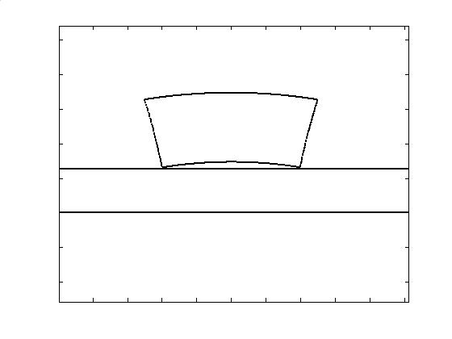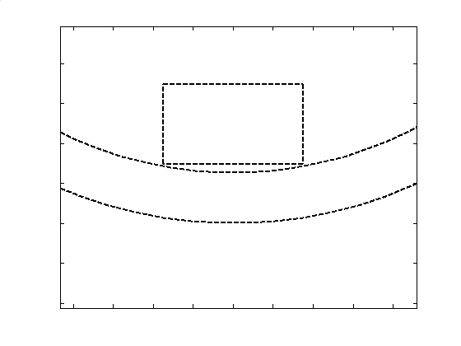
Border of computation
a
b
c

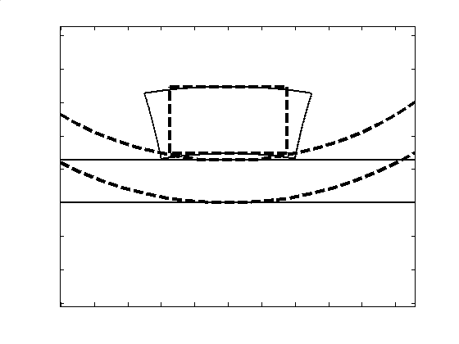

Fig. 3. Visualization of the geometrical transformation
a. Starting configuration
b. Equivalent configuration
c. Superposition of the two configurations

Into the software of the laboratory, we integrated a programmer of introduction of the geometrical, physical data and boundary conditions. These numerical tools are developed under Matlab® environment. The program thus developed applies to the magneto dynamic problems.
Table 1 shows the physical and geometrical characteristics of the starting configuration and those of the equivalent configuration:

sensor area $(m^{2})$ | $$7\text{.}{\text{10}}^{−6}$$
deformed sensor area $(m^{2})$ | $$8,\text{98}\text{.}{\text{10}}^{−6}$$
Frequency $(\text{Hz})$ | 240000
current injected (by whorl) $(\text{mA})$ | 4,573
whorls number | 328
conductivity of the load$(S\text{.}m^{−1})$ | 1000000
relative permeability | 1
thickness of plate $(m)$ | $$\text{1,27}\text{.}{\text{10}}^{−3}$$

Tab. 1. Physical and geometrical characteristics of the application

Table 2 shows the values of the powers calculated in the load, resistances, inductances and the impedances given by a traditional numerical calculation direct applied to the configurations: departure and that equivalent separately.
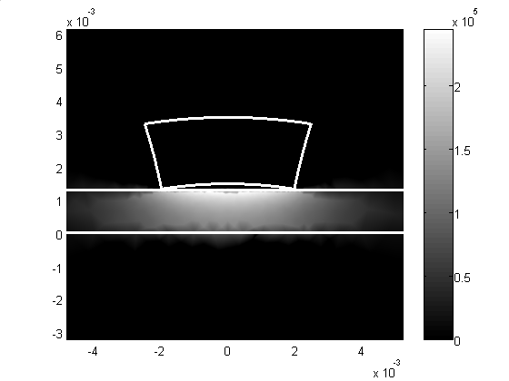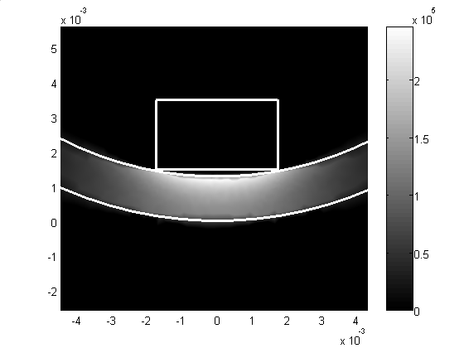

Fig. 4. Visualization of the Induced currents
a. Configuration of the departure
b. Equivalent configuration

Type of configuration | Plane | Cylindrical | Δ (%)
Dissipated power (Watt) | 0,1713 | 0,1731 | 1,05
Resistance (Ω) | 0,0716 | 0,0806 | 12,56
Inductance (H) | $$1,\text{5325}\text{.}{\text{10}}^{−7}$$ | $$1,\text{4914}\text{.}{\text{10}}^{−7}$$ | 2,68
Impedance (Ω) | 0,2419 | 0,2389 | 1,24

Tab. 2. Summary of the results

The variations obtained are very acceptable, from where validity of our model. These same variations can be improved, one increasing the degree of the specific geometrical transformation by elevation of the number of points to transform starting model to that are equivalent.
To confirm our observations validity precision of our model, we propose in what follows to carry out the calculation of the space evolution of magnetic induction (b) in a strongly significant area of the application and where the variations of the electromagnetic phenomena are very significant.
Indeed, we will evaluate the variation of (b) in two ways different on the level from the configuration from departure.
Initially we even calculate this variation of (b) on the segment of straight line AB (Figure 3.a) by modeling by the FEM the starting configuration it. It is thus about a traditional numerical calculation direct.

In the second time, we calculate this same variation of (B), by using the MEF in the same way as previously, but, this time on the arc CD of the equivalent configuration (Figure 3.b) obtained after the application of the geometrical transformation on the starting configuration. This variation of (b) thus obtained is brought back by opposite vectorial transformation to the starting configuration and will be confronted with that obtained initially by treating the model of the starting configuration. The values of the differences between the two manners of calculation of (b) define the degree of validity of the model.

-20
-15
-10
-5
0
x 10
-3
0
0.5
1
1.5
2
2.5
Width of the plate (m)
x 10
-4
(Tesla)
Direct traditionnel model
Model of the conformal mapping
Width of the plate (m)
-20
-15
-10
-5
0
1
2
3
4
5
6
7
0
x 10
-3
x 10
-5
(Tesla)
Direct traditionnel model

Model of the conformal mapping

Fig. 5. Comparison of the modules of Bx and By given by the two computations methods: direct and by conformal mapping

6. Conclusion
In this work we sought to know the state of the art as for the use of the transformations in conformity in the field of electromagnetism. This problem currently constitutes a field of exploration on behalf of the scientific community.
The validity of the geometrical transformation is checked in two dimensions on the unit: sensor, air-gap and load. It is bijective and preserves the local sizes and consequently, the total sizes. With an aim of calculating the magnetic potential vector and through magnetic induction, we checked the degree of validity of the vectorial transformation. In addition, our study facilitates the task with the people being interested in numerical modeling of the two-dimensional and three-dimensional systems with complex geometries. The latter constitute our medium-term prospects.

References
1. Rasolonjanahary JL., Thollon F.: Study of Eddy Currents Non destructive Testing System in Riveted Assemblies. In: IEEE Transaction on Magnetic, Vol 32, n°3, pp 1585-1588, May 1996.

2. Mziou, M.: Internal management report of the CEA, ref: STA/LCME/RT3746, October 1998.

3. Henrotte, F.: Modélisation des efforts électromagnéti-ques et leurs effets dans les structures quelconques (Modeling of the electromagnetic efforts and their effects in the unspecified structures) Doctorate Thesis of the University of Liege, Belgium, January 2001.

4. Chauveau, E.: Contribution au calcul électromagnéti-que et thermique des machines électriques (Contribution to the electromagnetic and thermal computation of the electric machines) Doctorate Thesis of the University of Nantes, French, November 2001.

