Variable Speed Wind Turbines using Induction Generators

Connected to the Grid: Digital Simulation versus Test Results

Lucian Mihet-Popa and Ion Boldea, Fellow, IEEE.

Dept. of Electrical Machines and Drives, “Politehnica” University of Timisoara
Blvd. V. Parvan no. 2, 300223 Timisoara, Romania
Tel. +40256-204402, E-mail:mihetz@yahoo.com, boldea@lselinux.utt.ro

Abstract – In this paper, the performance of two variable speed wind turbine concepts with induction generators connected to the grid is investigated. Variable-speed wind turbine generator systems have been modelled and simulated to study their steady state and dynamic behaviour. A doubly-fed induction generator of 11 kW fed by a vector controlled back-to-back PWM-VSI inverter on the rotor side and a cage rotor induction generator of 11 kW rating with a vector controlled back-to-back PWM-VSI inverter on the stator side have been tested and the results compared with digital simulations. It is shown by both modelling and laboratory tests that a doubly-fed induction machine can be used as a variable speed wind generator over a large speed range (±40 %). The cage rotor induction machine also allows good speed range and it should be used in low-power variable-speed systems, replacing the classical direct grid connected fixed speed wind generator systems. Its capacity to deliver reactive power is remarkable.

- INTRODUCTION

Wind turbines may be designed with either synchronous or asynchronous generators, and with various forms of direct and indirect grid connection of the generator. The vast majority of the installed power of wind turbines in the world is grid connected. Because the wind is highly variable, it is desirable to operate a wind turbine at variable speeds. Generally energy is generated using two operating modes of WTG [1-3]:
- Constant Speed – Constant Frequency (CSCF)
- Variable Speed – Constant Frequency (VSCF) control needs speed controller to obtain maximum power from the wind and a converter to change variable frequency of the generator to constant frequency of output voltage.
With variable speeds the turbine is able to operate at its maximum power for a given wind speed. Some of advantages of VSCF-WTG against CSCF-WTG are [3]:
- It generates more energy by operating on a larger wind speed range;
- It reduces stresses in the drive train due to flywheel effect of the rotor;
- It minimizes the audible noise when operating in light winds;
- It simplifies the mechanical design and reduces mechanical stress.
Due to the rapid development of power electronics, offering both higher power handling capability and lower price/kW, the application of power electronics in wind turbines will increase further [2].
The doubly fed induction generator can supply power at constant voltage and constant frequency while the rotor speed varies. This makes it suitable for variable speed wind energy applications. Additionally, when a bidirectional AC-AC converter is used in the rotor circuit, the speed range can be extended above synchronous speed and power can be generated both from the stator and the rotor.
Various types of power control strategies have been suggested for application in variable speed wind turbines [1-7]. One possible implementation scheme of adjustable speed generators consist of a synchronous generator and a power converter. The power converter, which has to be rated at 1 p.u. total system power, is expensive. Compared to direct-in-line systems, the doubly fed induction generator (DFIG) systems offer the following advantages [1, 3]:
- reduced inverter cost, because inverter rating is typically 25 % of total system power, while the speed range is ±(20-25) % around the synchronous speed;
- improved system efficiency;
- power factor control can be implemented at lower cost, because the DFIG system basically operates similar to a synchronous generator.
The most commonly concepts using the asynchronous generator with speed variation applied in wind turbine configurations are displayed in Fig. 1 [1, 2].
The variable speed wind turbines represent a new technology within wind power for large-scale applications and their models have to be set up for making power stability investigations. Therefore, this concept will be analyzed as follows.

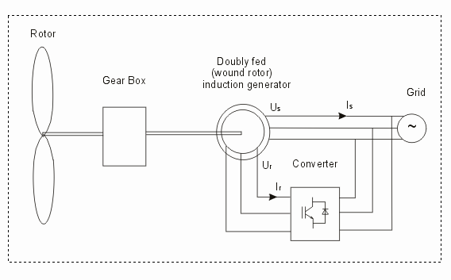
a)
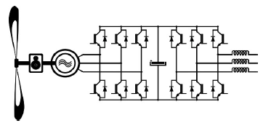
b)
Fig. 1. Standard variable-speed wind turbine configurations using doubly-fed induction machine, a), cage rotor induction machine, b).

- DOUBLY-FED INDUCTION GENERATOR BASED WIND TURBINES

The Doubly Fed Induction Generator (DFIG) is an induction machine with a wound slip ring rotor. This provides the machine with an additional power port, giving additional control opportunities that may be exploited in the wind power generating systems.
DFIG is implemented as a variable speed, constant frequency scheme, by applying a converter to the rotor terminals of DFIG. The wind rotor determines the rotor speed, and controlling the rotor currents may control the stator power of the DFIG. If the stator flux is chosen as a reference, the q-rotor current (I_{qr}) controls the stator reactive power (Q_{s}), and the rotor d-current (I_{dr}) controls the stator active power (P_{s}). Controlling the rotor q- and d-currents respectively may control the stator active and reactive power. The ability to supply / subtract power to / from the rotor makes it possible to operate the DFIG at sub- and super-synchronous speed, having constant voltage and frequency on the stator terminals. Furthermore it is possible to recover slip power in the rotor and supply it back into the power grid, through which the efficiency of the machine may be increased.

  - Control Strategy of the DFIG.
The control strategy is developed in the stator flux fixed reference frame. The input from the stator is in the stator fixed reference frame and rotor input in the rotor fixed reference frame. Rotor voltage output is in the rotor fixed reference frame. The control strategy for controlling the stator active and reactive power is based on the power decoupling. It means that the stator active and reactive power feedback loops are required, as can be seen in Fig. 2.
The control scheme consists of two control loops: an inner loop for controlling the rotor current, and an outer loop for controlling the stator active and reactive power. The stator voltages and currents are measured in the stator fixed reference frame. In addition, the stator active and reactive power is calculated in the stator fixed reference frame. From the stator quantities, the stator flux is calculated, and the amplitude and angle of the resulting stator flux is found. The measured stator power (Ps, Qs) is compared to the power references (Ps*, Qs*), and the errors (e_{Ps}, e_{Qs}) are fed to the power regulator. From the power regulator the reference values of rotor d- and q-currents are calculated using power decoupling. The reference values of rotor currents are compared to the rotor currents measured in the rotor fixed reference frame and transformed to the stator flux fixed reference frame, and the errors are fed to the current regulators. After the current regulator, feed forward compensation is used for decoupling rotor voltages and currents and then the reference values of rotor voltages are transferred to the rotor fixed reference frame and fed to the stator flux asynchronous vector modulation (SFAVM).
Since the power is independent of the choice of reference frame, the calculation of stator power may be performed in any reference frame. If the stator power is calculated in the stator fixed reference frame, the number of transformations to be performed may be minimized. The stator power is calculated using equations (1) and (2):
$\text{Ps}=\frac{3}{2}∗\left(u_{{\text{ds}}^{s}}i_{{\text{ds}}^{s}}+u_{{\text{qs}}^{s}}i_{{\text{qs}}^{s}}\right)$.................(1)
$\text{Qs}=\frac{3}{2}∗\left(u_{{\text{ds}}^{s}}i_{{\text{qs}}^{s}}−u_{{\text{qs}}^{s}}i_{{\text{ds}}^{s}}\right)$................(2)
The measured stator power is compared to the reference values of Ps and Qs, and the error signals are fed to the power regulator.
If the stator flux fixed reference frame, the d-axis stator flux is equal with zero and the stator active and reactive power may be expressed as in equations (3) and (4):
$\text{Ps}=−\frac{3}{2}⋅\frac{p}{2}⋅ω_{e}⋅λ_{{\text{qs}}^{e}}⋅i_{{\text{dr}}^{e}}$.................(3)
$\text{Qs}=\frac{3}{2}⋅\frac{p}{2}⋅ω_{e}⋅λ_{{\text{qs}}^{e}}⋅\frac{λ_{{\text{qs}}^{e}}−M⋅i_{{\text{qr}}^{e}}}{L_{s}}$...(4)

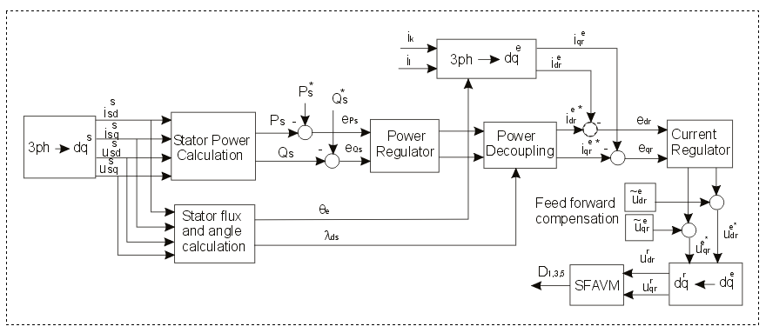

Fig. 2. Control scheme of DFIG with measurement of stator voltage and stator and rotor currents, implemented in Matlab-Simulink. The rotor d-and q- axis are compensated by use of feed-forward loop.

As can be seen in (3) and (4) power decoupling may be obtained by controlling the rotor d- and q-currents. This means that power decoupling is obtained by simply applying to the power rotor regulator output as a reference to the rotor current loop. The output from the power decoupling is the rotor d- and q-current references, as shown in Fig. 3.

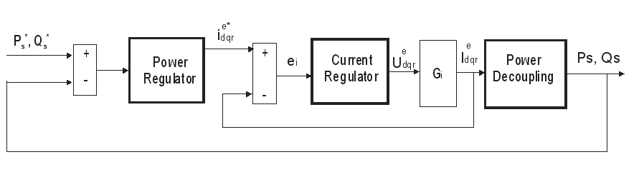
Fig. 3. Simplified control scheme with an inner rotor current control loop, and an outer power control loop. Full decoupling between rotor currents is assumed.

The control scheme is implemented as shown in Fig. 3. The current regulator is designed and the closed loop transfer function (Gi) for the current loop is found. The power regulator is also designed and the closed loop performance of the power loop is evaluated.
The control scheme (Fig. 2) and the regulators are implemented in a complete simulation model also including the DFIG model, rotor converter model and the control program developed in Ansi C and converted in Matlab-Simulink function and the C-file may be executed in Simulink by means of the Matlab MEX-function., more details can be found in [8]. The model of the DSP implemented in Simulink is shown in Fig. 4:

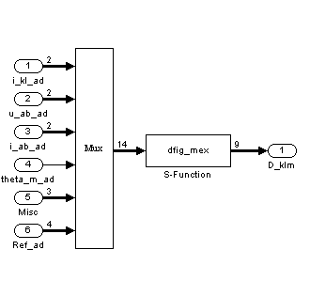
Fig. 4. Model of the TMS320C32 – DSP developed in Simulink. The control algorithms written in the Ansi-C language executed using the Matlab mex S-function.

The advantage of implementing the Ansi-C file in Simulink is the direct connection to the implementation in DSP, and decrease in simulation time.

B. Simulation results.

In order to evaluate the performance of implemented control strategy presented before and to analyze system response in steady state and transients the DFIG was subject to step changes in active and reactive load power with the machine driven at both sub- and super-synchronous speeds.
The transient response due to a step change in reference active power control is shown in Fig. 5. The Fig. 5 a) shows the response to a step change in the active load power from 0 to 1.5 kW, while the reference of reactive power is maintained at 0 and the corresponding stator active and reactive power of the machine are monitored. Similar transient response for generating condition is given in Fig. 5 b). When a step in active power is applied (t=1sec), the reactive power shows small additional oscillations. It is also observed that (Ps) reaches its set value in approximately 10 ms. The simulation results indicate that the generator follows the reference very fast and is dynamically stable. It may be noted from these waveforms, that the transient responses in (Ps) and (Qs) are perfectly decoupled. The DFIG was driven by the drive system at 1125 rpm (75% of synchronous speed-sub synchronous speed operation mode).

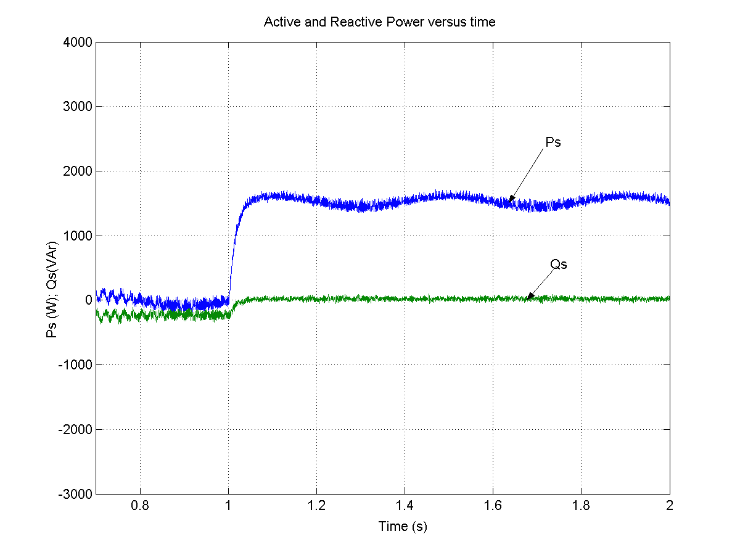
a)
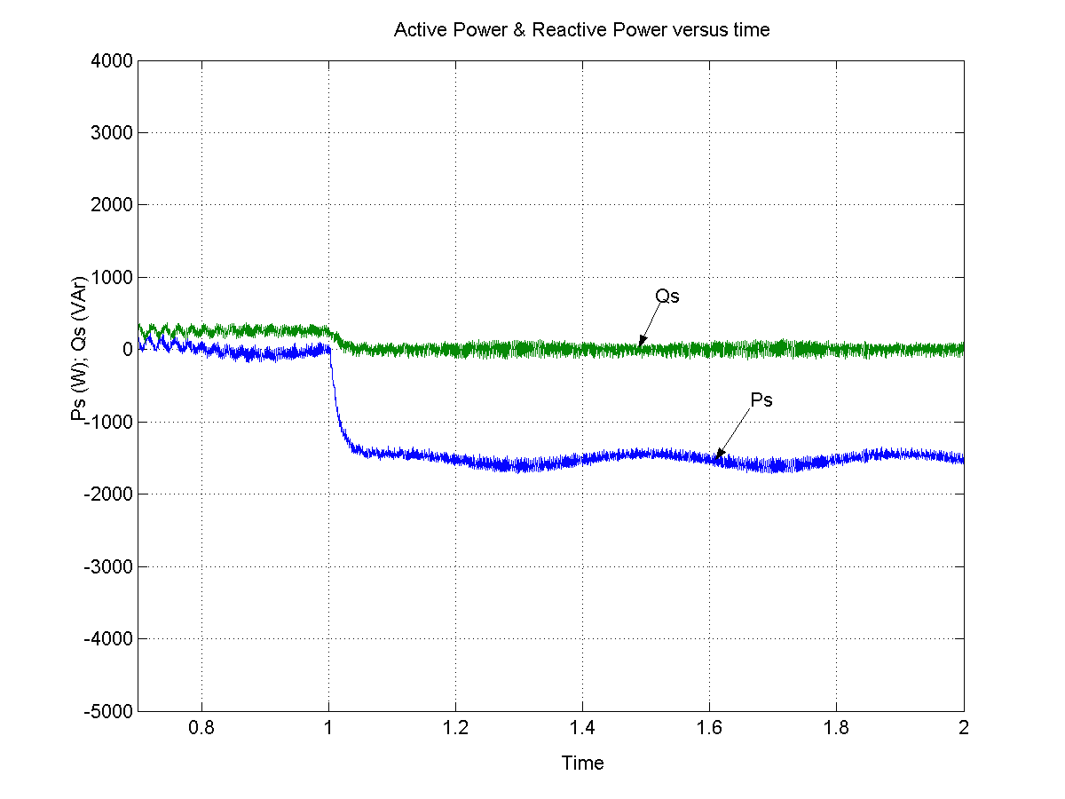
b)

Fig. 5. Simulated stator active and reactive power at 1125 rpm with a step change in active power command from 0 to 1500 W (a) and with a step change in active power reference from 0 to -1500 W at t=1s, b).

The validity of the model presented before is also verified by simulating a step in rotor speed and sample the stator active and reactive power, electromagnetic torque and stator and rotor currents. All simulations are performed with constant DFIG parameters. The DFIG is driven by the drive system at 1125 rpm (sub-synchronous mode-75 % of synchronous speed), and the reference speed is changed at t=2seconds to 1875 rpm (super-synchronous operation mode-125 % of synchronous speed). The speed and torque response are shown in Fig. 6 b). The mechanical system is modelled using a first order approximation, where the time constant is determined from a step in rotor speed. Figures 6 a) illustrates the simulated stator active and reactive power of the DFIG as a function of time. The stator active power and stator reactive power are controlled independently, by controlling the rotor currents. If the speed increases so that the machine is operating in generating mode at super-synchronous speed, the stator active power and electromagnetic torque change direction from the sub-synchronous operation (Fig. 6).

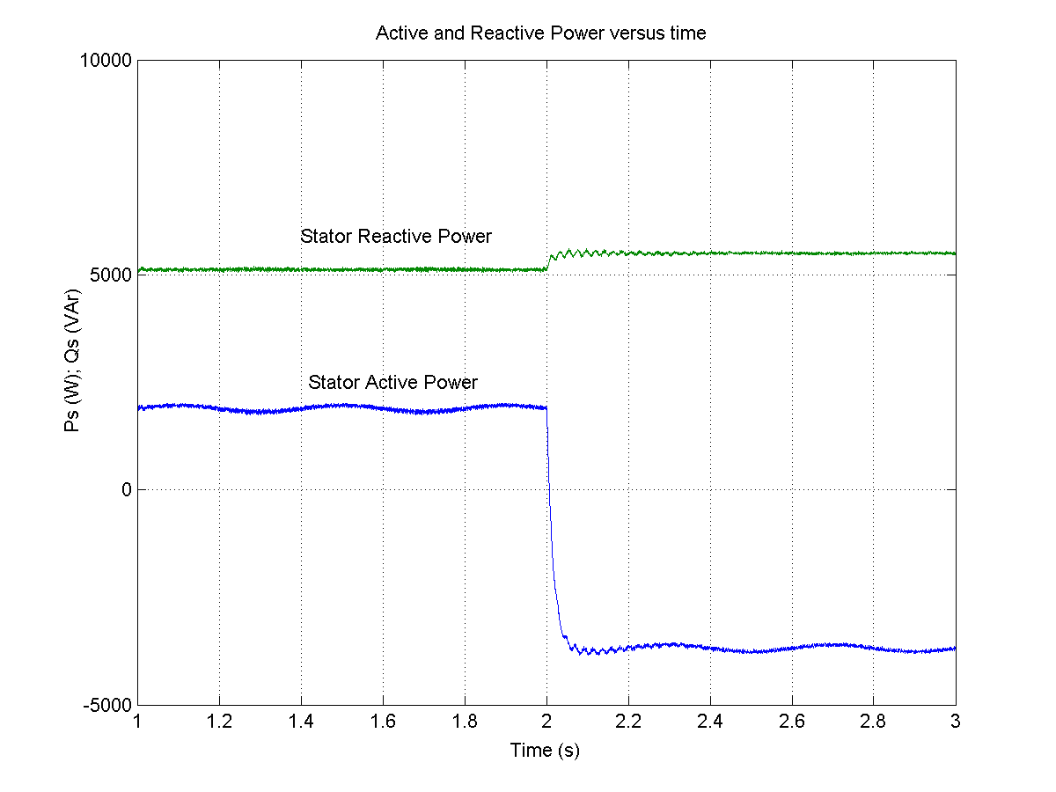
a)
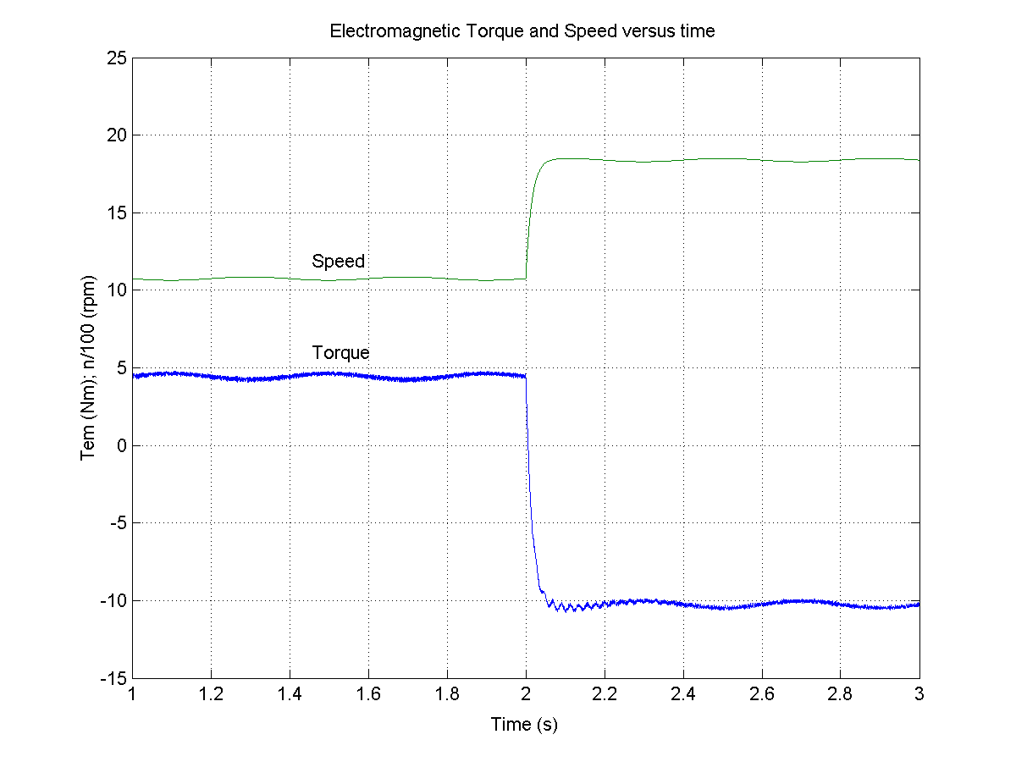
b)
Fig. 6. Simulation of the stator active and reactive power (a) and electromagnetic torque and speed (b) as a function of time. The speed reference of the drive system is changed at t=2 s from 1125 rpm to 1875 rpm.

III. EXPERIMENTAL SYSTEM

The experimental system is a scaled model of a 2MW variable speed wind generator system. It is composed of four main components: a DFIG with a four quadrant ac-to-ac converter connected to the rotor windings, a drive system and a control processor unit.
The generator is a wound rotor induction generator (doubly fed induction generator - DFIG), with slip rings, rated at 11 kW provided with a gearbox. The wind turbine rotor is emulated by use of a drive system scaled for driving the DFIG; the drive system is composed of a 15 kW induction motor and a 22-kVA-frequency converter. Two back-to-back PWM-VSI converters with a standard control system, with a DC-link including a DC capacitor filter are used to control the rotor currents, active and reactive power flow. The grid converter is designed to give unity power factor and is controlled by the Control Processor (CP) – board via a PC. It works as an active rectifier supplying the rotor converter with a constant DC voltage. The measurement and control system is composed of a PC with a digital signal processor (TMS320C32 DSP), interfaces and transducers for measuring stator and rotor currents, stator voltages, and rotor speed, as can be seen in Fig. 7.

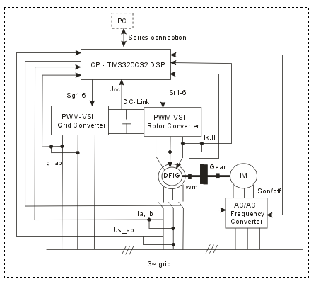
Fig. 7. Schematic diagram of the experimental set-up.

IV. COMPARISON BETWEEN SIMULATION and EXPERIMENTAL RESULTS

The equipment used to obtain the test data was described in the previous sub-section.
Tests and simulations were performed to examine the system performance in steady-state and to validate the Matlab-Simulink implemented system developed for a variable speed wind turbine with DFIG.
Fig. 8 and Fig. 9 shows the steady-state waveforms of stator currents and stator voltages of the DFIG running at 1475 rpm (sub-synchronous speed operation mode) and stator power of 4 kW.
The Fig. 8 shows a comparison between simulated and measured stator currents of DFIG, while in Fig. 9 is presented a comparison between simulated (b) and measured (a) stator voltages of DFIG. The measured data were acquired by an Oscilloscope, while the simulation results were performed by Matlab / Simulink. The correspondence between simulation and experiments is very good as can be seen in Fig. 8 and Fig.9.

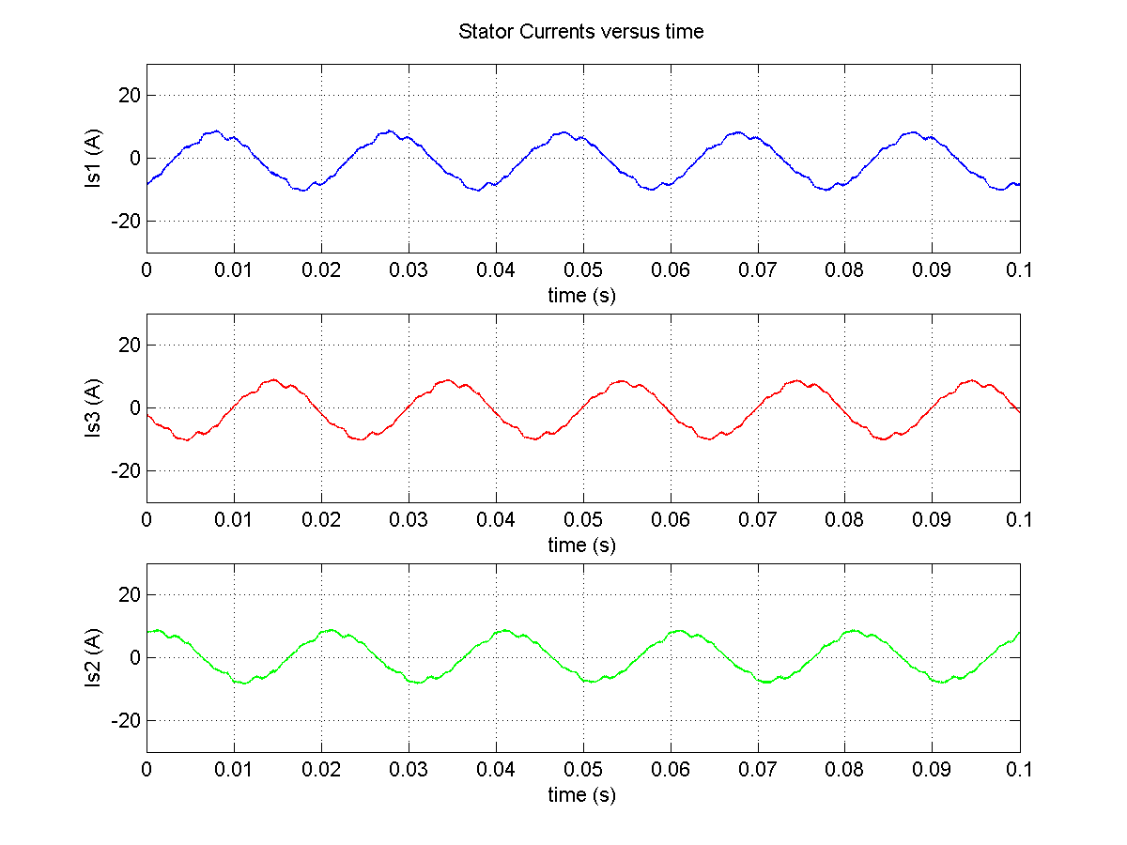
a)
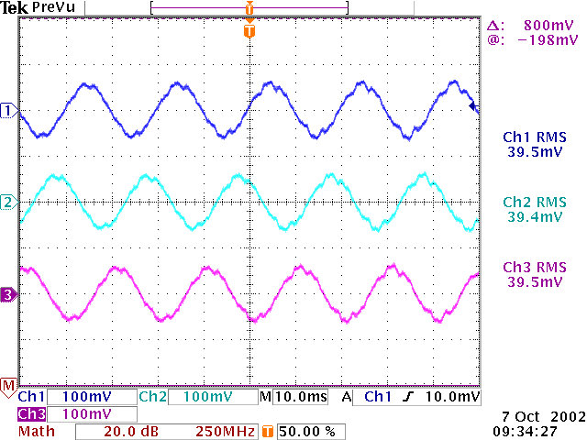
b)
Fig. 8. The simulated stator currents of DFIG (a) using Matlab-Simulink and measured stator currents (b) by an Oscilloscope in steady-state at P=4 kW and n=1475 rpm (sub-synchronous operation mode). Scaling factor of measured stator currents is 4 (mV/A).
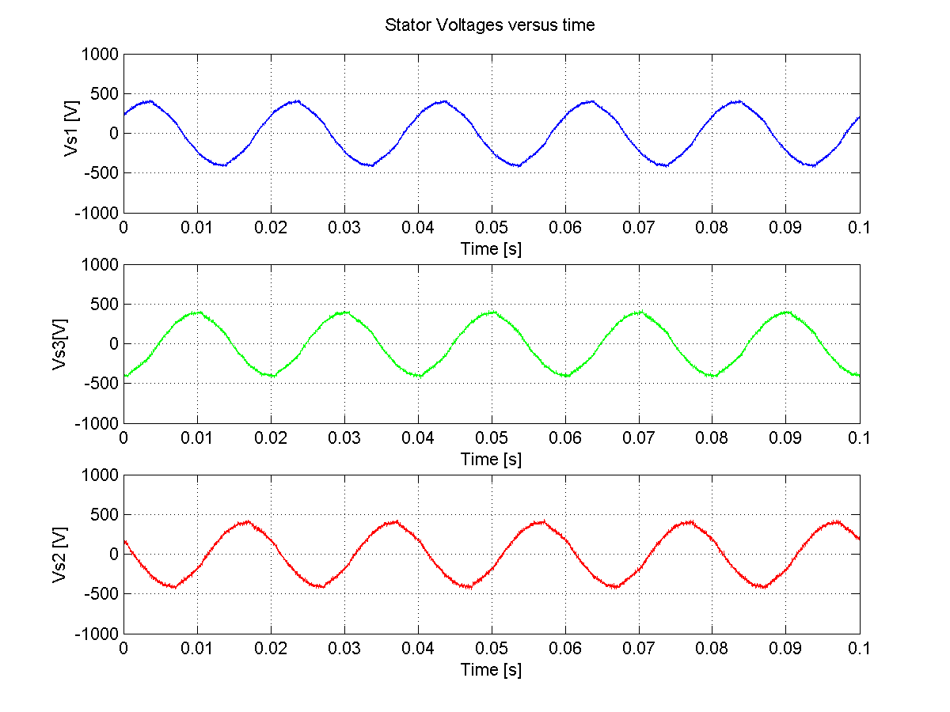
a)

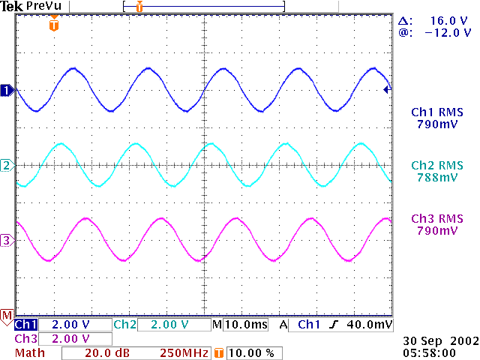

b)

Fig. 9. The Simulation of stator voltages in steady-state (a) and measured line – line stator voltages of DFIG acquired by an Oscilloscope TDS 540. Scaling factor of measured stator voltages is 2 (mV/V).

V. VARIABLE SPEED WIND TURBINES USING CAGE ROTOR INDUCTION GENERATOR

The adjustable speed generators systems with cage rotor induction generator are commonly used in low power variable-speed wind turbines replacing the classical direct grid connected fixed speed drives. The goals that can be achieved by using this topology are to increase the energy production especially in the low wind range, eliminate the capacitor bank for reactive power compensation and allow both grid-connection and stand-alone operation modes.
In this section a flexible development platform using dSPACE DS1103 card was used in order to control the power converters for an 11 kW wind generator system. The back-to-back voltage source converter is a bi-directional power converter consisting of two conventional voltage source inverters rated 18.5 kW/400 V, as shown in Fig. 10. One frequency inverter is connected to the induction generator and uses the standard vector flux control to regulate the speed and provide magnetizing flux. The second one is connected to the grid through an LCL filter and is working as an active rectifier. Both inverters are controlled via dSPACE 1103 system connected to a PC.
To achieve full control of the output, the DC-link voltage must be boosted to a level higher than the amplitude of the grid voltage. The power flow of the grid side converter is controlled in order to keep the DC-link voltage constant. A technical advantage of this topology is the capacitor decoupling between the grid converter and the generator converter. This decoupling offers separate control of the two converters.
The complete grid-side controller including DC-link, grid inverter, space vector modulator (SVM) and grid is shown in Fig. 11.

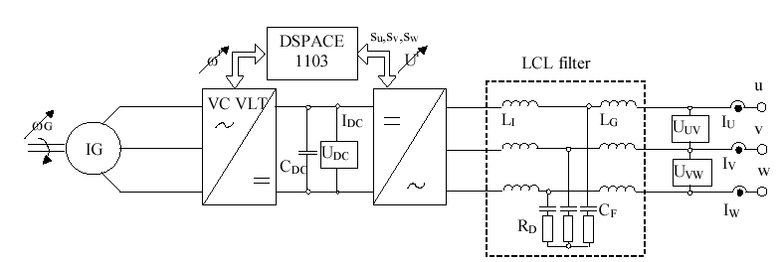
Fig. 10. Variable speed wind turbine using cage rotor induction machine test system.

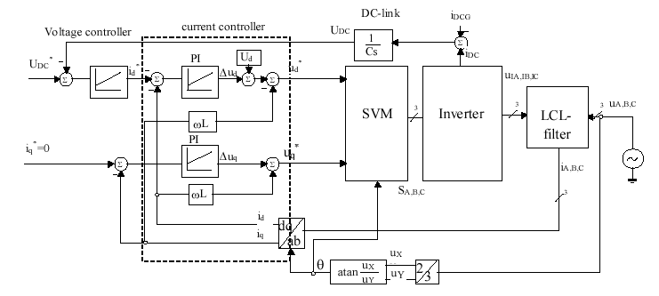

Fig. 11. A schematic block diagram of grid converter side controller.

The current controller is designed in d-q synchronous reference frame using two PI regulators for each component. Grid voltages are measured and feed-forward to compensate grid voltages. Cross couplings are compensated with (ωL) terms, assuming that (dω/dt) = constant. PI regulators are used to determine appropriate voltages for the reference currents. The reference current (i_{q}*) in the q-branch of the current loop is set to zero in order to achieve 0 phase angle between voltage and current and therefore unity power factor.
The wind emulator is composed of a cage rotor induction machine supplied by a frequency converter used to control the mechanical power on the generator shaft.

A. Experimental results

There are two modes of operation of grid converter, rectifying mode and generating mode, as can be seen in Fig. 12. The data were acquired by a PC via dSPACE 1103 card.

a)
b)
Fig. 12. Grid phase current and voltage at nominal power (11 kW) in rectifying mode (a) and generating mode (b), acquired by a PC via dSPACE card.
Fig. 13 illustrates an acquisition of data in steady-state using an Oscilloscope (TDS 3014) at nominal load (11 kW) in generating mode (Fig. 13a) and in motoring mode (Fig. 13b). In rectifying mode phase voltage is in phase with phase current, while the difference in generating mode has 90 degrees.
The performances of the system are shown in Fig. 14, under sudden changes in load. It shows that the DC voltage is maintained almost constant during transient conditions. DC-link voltage drop was under 4 % when applying disturbance of nominal load and disturbance rejection time was less than 60 ms, as can also be seen in Fig. 14.

a)

b)

Fig. 13. Phase current (ia), phase voltage (ua) and DC voltage (U_{DC}) at nominal load in generating mode, (a), and in rectifying mode (b), acquired by an Oscilloscope.

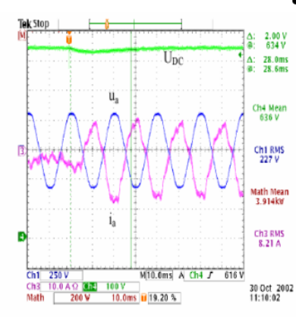
a)
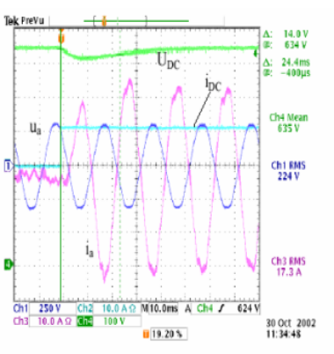
b)

Fig. 14. Step load change from no load to 40 % of nominal load (11 kW), a) and from no load to nominal load, b).

VI. DISCUSSION and CONCLUSION

In this paper two variable speed wind turbines concepts using induction generators connected to the grid are presented.
The simulation results were compared with experimental results and good agreement was obtained. The simulation also shows good dynamic performance regarding power control when the rotor speed is varied. Measurements obtained confirm the theoretical results and validate the simulation program of the variable-speed constant frequency system with the DFIG for wind power generation applications.
A control scheme is developed for decoupled control of active and reactive stator power of the DFIG. The control strategy is a cascade control, has two control loops. An inner rotor current control loop and an outer stator power control loop. The two-phase d-q reference system with the q-axis aligned along the stator flux is chosen for implementation to realize decoupling of active and reactive power. The simulations developed in Matlab-Simulink show that full power decoupling is obtained in the complete operating range between 60 % and 140 % (± 40 %) of nominal speed. The doubly fed induction generator system presented in this paper offers many advantages to reduce cost and has the potential to be built economically at power levels above 1.5 MW, e.g. for off-shore applications. Additionally, when a bidirectional AC-AC converter is used in the rotor circuit, the speed range can be extended above synchronous speed and power can be generated both from the stator and the rotor. The two back-to-back PWM converters in the rotor circuit result in low distortion currents, reactive power control and both sub- and super-synchronous operations. Another advantage of this type of DFIG drive is that the rotor converter need only be rated for a fraction of the total output power (20-25 % of the total generator power), the fraction depending on the allowable sub- and super-synchronous speed range.
A flexibile development platform with DS1103 dSPACE is used to implement and test a control strategy for 11 kW variable-speed wind turbines with a cage rotor induction generator. Using this configuration is possible to increase the energy production especially in the low wind range, up to 1 MW per unit that can be used in remote places. Its capacity for deliver reactive power is remarkable and allows both grid connection and stand-alone operation modes.

ACKNOWLEDGEMENT
The authors would like to thank the Institute of Energy Technology at University of Aalborg, Denmark, for letting us use their dedicated test rigs for the scope.

VII. REFERENCES

[1] Siegfried Heier, “Wind energy conversion systems”, book, John Wiley & Sons Inc., New York, 1998.
[2] L.H. Hansen, L. Helle, F. Blaabjerg, E. Ritchie, S. Munk-Nielsen, H. Bidner, P. Sorensen and B. Bak-Jensen, ”Conceptual Survey of Generators and Power Electronics for Wind Turbines”, Riso-R-1205 (EN), December 2001.
[3] S. Muller, M. Deicke and Rik W. De Doncker, “Doubly Fed Induction Generator Systems for Wind Turbines”, IEEE Industry Applications Magazine, May-June 2002, pp. 26-33.

[4] R. Pena, J.C. Clare, G.M. Asher, “Doubly Fed Induction Generator using Back-to-Back PWM Converters and its Application to Variable Speed Wind Energy Generation”, 1996, IEE Proceedings on Electrical Power Applications, Vol. 143, No. 3, pp. 231-241.
[5] Hirofumi Akagi and Hikaru Sato, “Control and Performance of a Doubly-Fed Induction Machine Intended for a Flywheel Energy Storage System”, IEEE Transaction on Power Electronics, Vol. 17, No. 1, January 2002, pp. 109-116.
[6] Rajib Datta and V.T. Ranganathan, “Direct Power Control of Grid-Connected Wound Rotor Induction Machine without Rotor Position Sensors”, IEEE Transactions on Power Electronics, Vol. 16, No. 3, May 2001, pp. 390-399.
[7] D.S. Zinger, E. Muljadi, “Annualized wind energy improvement using variable speeds”, Industrial & Commercial Power Systems technical Conference, 1997. Conference Records, Papers presented at the 1997 Annual Meeting, IEEE 1997, 11-16 May 1997, pp. 80-83.
[8] L. Mihet-Popa, “Wind Turbines using Induction Generators connected to the grid”, Ph. D Thesis, POLITEHNICA University of Timisoara, October 2003.

VIII. Appendices: Experimental systems ratings

TABLE 1
NAMEPLATE DATA for LEROY SOMER 11 kW WOUND ROTOR SLIP RINGS GENERATOR.

LEROY SOMER, MOT. ~ FLSB 180 M4 B3, No. 14618900HG01, kg: 220
IP55 IK | 1 cl. F | 40 °C | S1
V | Hz | 1/min | KW | cosϕ | A
690Y | 50 | 1460 | 11 | 0.81 | I_{S}=13
V_{R}=1700 |  |  |  |  | I_{R}= 6.1
DE | 6310 | 15cm³ | 11000 H 50/60 Hz
NDE | 6310 | 15cm³ | 11000 H 50/60 Hz

TABLE 2
NAMEPLATE DATA for 11 kW CAGE ROTOR INDUCTION MACHINE and INVERTERS TYPE.

Nominal power-11 kW | Inverters type-VLT 5022
Stator current – 16 A | Supply voltage: (380-500) V
Grid phase voltage – 230 V | Output current – 37.5 A
Grid frequency – 50 Hz | Input current – 37.5 A
 | DC Voltage – 700 V

